Spring

1. Root Tag🡺<beans default-init-method=”” default-destroy-method=”” default-autowire=””>
2. Core and beans🡺These modules provide IOC and Dependency Injection features.
3. Context module supports internationalization (I18N), EJB, JMS, Basic Remoting.
4. Expression Language is an extension to the EL defined in JSP. It provides support to setting and getting property values, method invocation, accessing collections and indexers, named variables, logical and arithmetic operators, retrieval of objects by name etc.
5. Dependency Injection (DI) is a design pattern that removes the dependency from the programming code so that it can be easy to manage and test the application.

Or

The basic concept of the Dependency Injection is that framework provides the dependencies of class itself.

We need not create the objects instead we just define how they should be created and IOC container will create the objects for us.

1. Bean Tag contents

<bean

id=”unique”

class=”fully qualified”

scope=”singleton(by default)/prototype/request/session/global-session”

init-method=””

destroy-method=””

abstract=”true/false”

autowire=”no(default)/byType/byname/constructor” 🡺 AutoDetect is deprecated

parent=”id of the bean which is parent to this bean>

>

<property name =”” value=””>

</bean>

1. <bean>

<constructor-arg value =”” type=””>

</bean>

1. <property name =”” ref =”id of the”>

Or

<property name =””>

<ref bean=” id of the referencing bean”/>

</property>

1. <alias name =”fromName” alias=”toName”/>
2. Two famous Spring Containers 🡺 BeanFactory and ApplicationContext
3. BeanFactory implementer🡺 XMLBeanFActory(new ClassPathXmlResource(file name));
4. ApplicationContext 🡺 ClasspathXmlApplicationContext
5. Collections🡺
6. Set🡺

<bean ------- >

<property name =””>

<set>

<value>”Value1”</value>

<value>”Value2”</value>

</set>

</property>

<bean>

<bean ------- >

<property name =””>

<set>

<ref bean=”id of the bean”/>

<ref bean=”id of the bean”/>

</set>

</property>

<bean>

Similarly we have for list

1. Map

<bean >

<property name =””>

<map>

<entry key =”” value =”value1”/>

<entry key =”” value =””/>=

<entry key =”” value =”value2”/>=

</map>

</property>

<bean>

<bean >

<property name =””>

<map>

<entry key-ref =”” value-ref =”value1”/>

<entry key-ref =”” value-ref =””/>=

</map>

</property>

<bean>

1. Props🡺 is a sub class of HashTable/HashMap where both key and value are string type
2. P-namespace 🡺

<bean ----- >

<p:propertyName=”Value”/>

</bean>

1. Spring Modules
2. Test
3. Core Container🡺 core, context, bean, spel
4. AOP
5. Messaging
6. Aspects, instrumentation
7. Data Access Integration 🡺 JDBC, ORM
8. Web🡺 Servlet🡺 for MVC support
9. Life Cycle hooks
10. Initializing bean🡺 afterPropertiesSet()
11. DisposableBean🡺 destroy
12. Sequence of Life Cycle hooks is 🡺
13. Instantiation and Initialization
14. Property set
15. setBeanName()
16. SetBeanFactoryAware()
17. setApplicationContextAware()
18. BeanPostProcessors🡺 postProcessorBeforeInitialization
19. InitializingBean 🡺 afterPropertiesSet()
20. BeanPostProcessors🡺 postProcessorAfterInitialization
21. Custom init method
22. Ready to use bean
23. DisposableBean🡺destroy method
24. Custom destroy Method

Note🡺 in order to perform destroy operation then I have to use registerShutdownHook() method of the AbstractApplicationContext

1. Autowiring feature of spring framework enables you to inject the object dependency implicitly. It internally uses setter or constructor injection. It requires the **less code** because we don't need to write the code to inject the dependency explicitly.
2. No/byname/bytype/constructor/autodetect 🡺 autodetect is deprecated from spring 3
3. Annotations 🡺
4. @Configuration
5. @Bean
6. @Required
7. @PostConstruct
8. @PreDestroy
9. @Scope(“”)
10. @Autowired
11. @Qualifier
12. @Aspect
13. @After
14. @Before
15. @Around
16. @AfterReturning()
17. @AfterThrowing()
18. @Pointcut(joint points)
19. <context: annotation-config />
20. <context:component-scan base-package =””/>
21. AOP breaks the program logic into distinct parts (called concerns). It is used to increase modularity by **cross-cutting concerns**.
22. A **cross-cutting concern** is a concern that can affect the whole application and should be centralized in one location in code as possible, such as transaction management, authentication, logging, security etc.
23. AOP concepts and terminologies are as follows:

* Join point🡺 Join point is any point in your program such as method execution, exception handling, field access etc. Spring supports only method execution join point.
* Advice🡺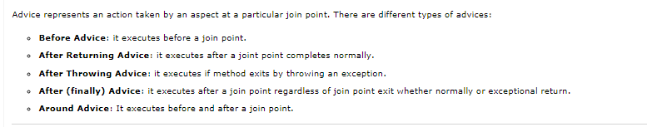
* Pointcut🡺 It is an expression language of AOP that matches join points.
* Introduction🡺 **NEEDED MORE PRACTICAL EXPLANATION**
* Target Object🡺 It is the object i.e. being advised by one or more aspects. It is also known as proxied object in spring because Spring AOP is implemented using runtime proxies.
* Aspect🡺 It is a class that contains advices, joinpoints etc.
* Interceptor🡺 It is an aspect that contains only one advice. 🡺 **NEEDED MORE PRACTICAL EXPLANATION**
* AOP Proxy
* Weaving🡺 It is the process of linking aspect with other application types or objects to create an advised object. Weaving can be done at compile time, load time or runtime. Spring AOP performs weaving at runtime.

1. 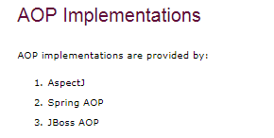
2. 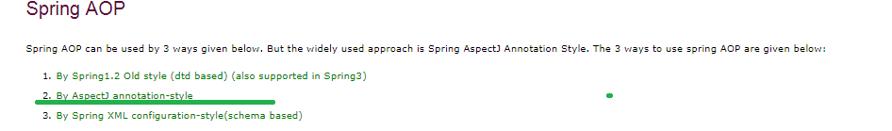

# **Spring AOP AspectJ Annotation Example**

1. The **Spring Framework** recommends you to use **Spring AspectJ AOP implementation** over the Spring 1.2 old style dtd based AOP implementation because it provides you more control and it is easy to use.
2. **@Aspect** , **@Pointcut** , **@Before, @After, @AfterReturning, @Around, @AfterThrowing**
3. Understanding point Cuts🡺
4. 
5. 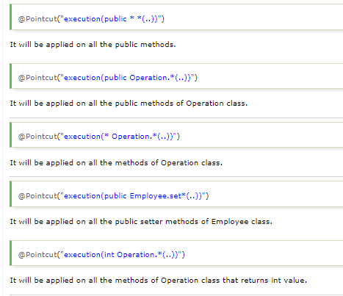
6. 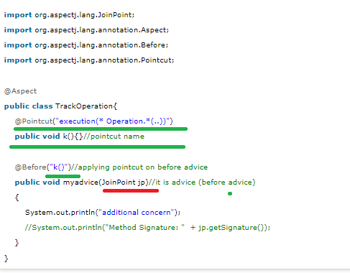

Explanation🡺

Green color🡺See here first Pointcut expression is declared on some method and that method name is used as input to @Before advice

**Red Color🡺 needed more info on this**

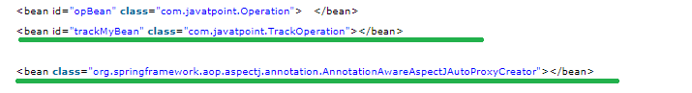

Where Operation class has BL

1. Similarly🡺 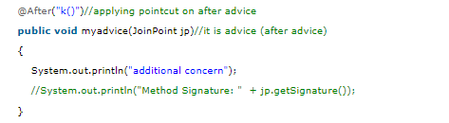
2. 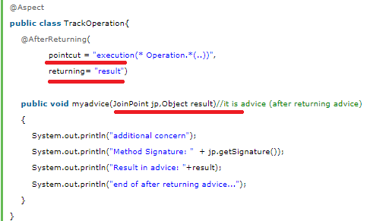
3. 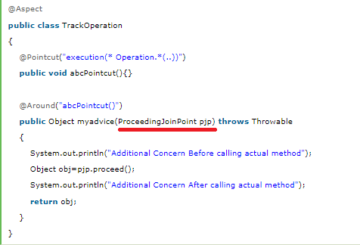 🡺 **needed more information on ProceedingJoinPoint and JoinPoint(See below)**
4. 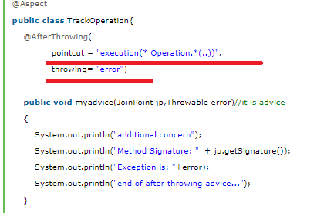
5. Spring JDBC Support 🡺 not used in my real time application so leaving this
6. JPA (Java Persistent API) is the sun specification for persisting objects in the enterprise application. It is currently used as the replacement for complex entity beans.

Note🡺 ms EJB 3 is JPA 1 specification

1. **Spring Data JPA API provides JpaTemplate class to integrate spring application with JPA.**
2. Example of Spring with JPA
3. Entity class🡺

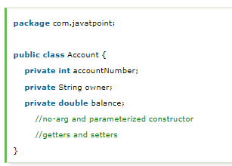

1. Mapping file(in case of XML Based application)

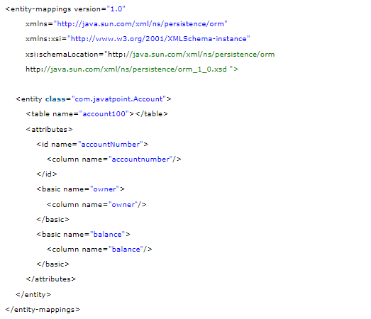

1. Persistence.xml 🡺 in case of Without Spring then this persistence.xml file will have all database configuration information’s like driver class, url, pwd, user name and etc.

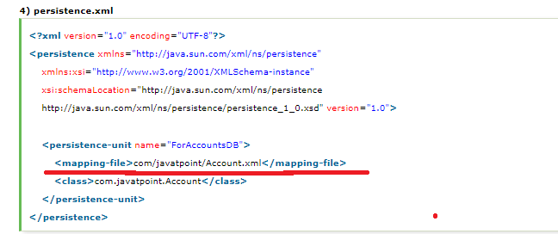

1. applicationContext.xml 🡺 (ms or spring-beans.xml file) will have all syntax rt from creating EMF, Transaction and etc. 🡺 **COMPARE CNA AND JAVATPOINT APPLICATIONCONTEXT.xml files**
2. 
3. 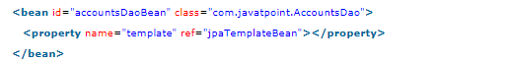
4. 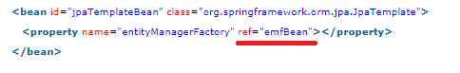
5. 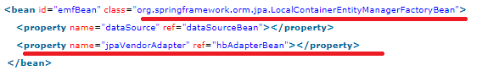
6. 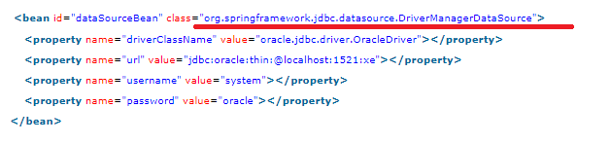
7. 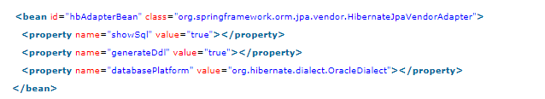
8. 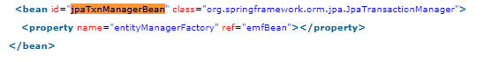

**Note🡺 needed more information on Transaction**

1. **Dao class 🡺 JpaTemplate has all JPA’s Curd method**
2. Dao 🡺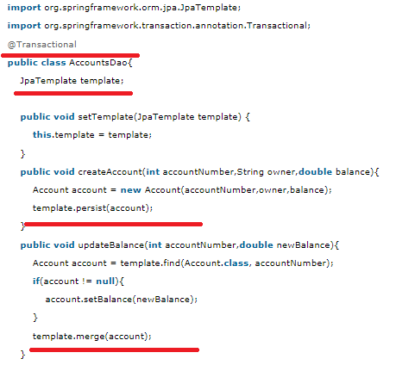

**NEEDED MORE INFORMATION ON @Transactional**

# **Hibernate and Spring Integration**

1. if we are going to integrate the hibernate application with spring, we don't need to create the hibernate.cfg.xml file. We can provide all the information in the applicationContext.xml file.
2. 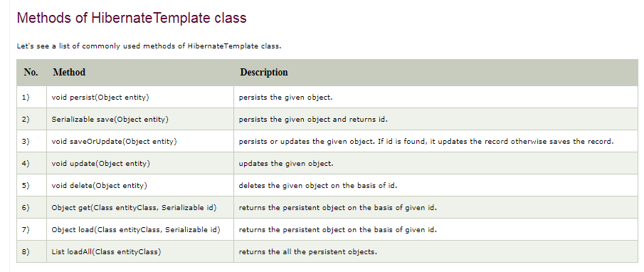
3. Steps,
4. **create the table in the database**
5. **Create Entity class**
6. **employee.hbm.xml(ms in case of XML based configuration)**

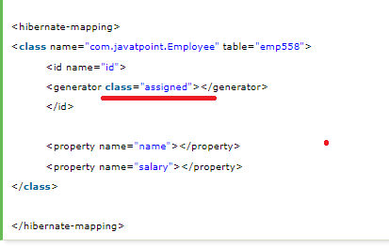

1. 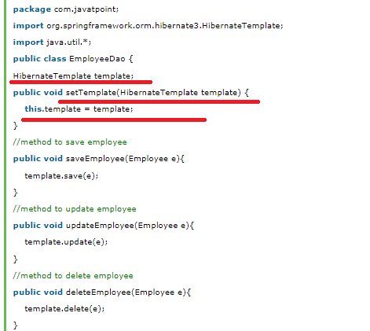 🡺 note HibernateTemplate has a Hibernate Persistence methods

Note🡺Spring with JPA or Hibernate does not uses EM or Session directly to do curd but uses JpaTemplate and HibernateTemplate 🡺 look into this in deep

1. *applicationContext.xml*
2. 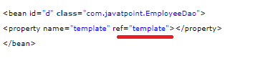
3. 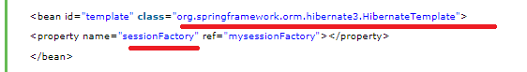
4. 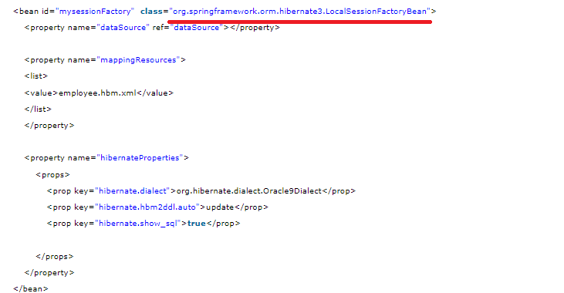
5. 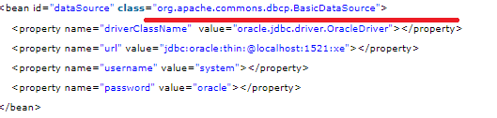
6. SPEL🡺 **I have not used it in my application 🡺 so see it later**

# **What is deadlock?**

# **Spring MVC Tutorial**

1. In Spring Web MVC, **DispatcherServlet** class works as the front controller. It is responsible to manage the flow of the spring mvc application.
2. The **@Controller** annotation is used to mark the class as the controller in Spring 3.
3. The **@RequestMapping** annotation is used to map the request url. It is applied on the method.

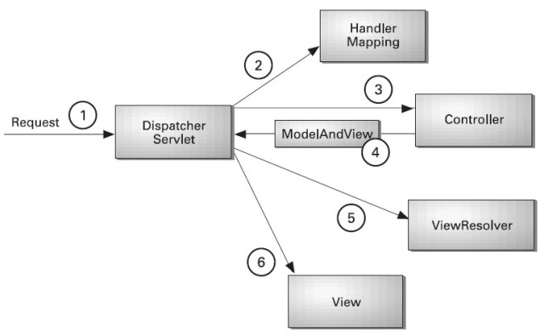

Explanation🡺 all the incoming request is intercepted by the DispatcherServlet that works as the front controller. The DispatcherServlet gets entry of handler mapping from the xml file and forwards the request to the controller. The controller returns an object of ModelAndView. The DispatcherServlet checks the entry of view resolver in the xml file and invokes the specified view component.

1. Steps for a mvc app,
2. 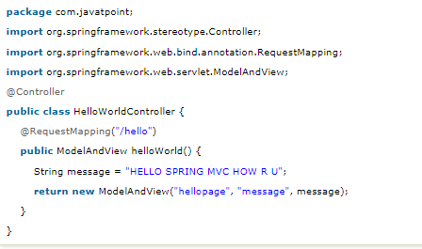
3. In web.xml file, we are specifying the servlet class DispatcherServlet that acts as the front controller in Spring Web MVC. All the incoming request for the html file will be forwarded to the DispatcherServlet.

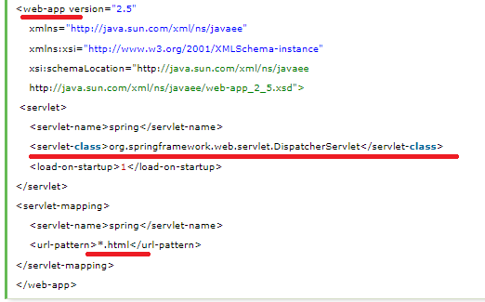

1. 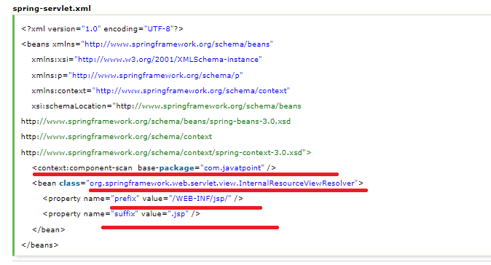

Expalnation🡺 The **context:component-scan** element defines the base-package where DispatcherServlet will search the controller class.

1. 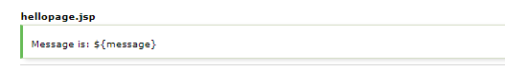
2. 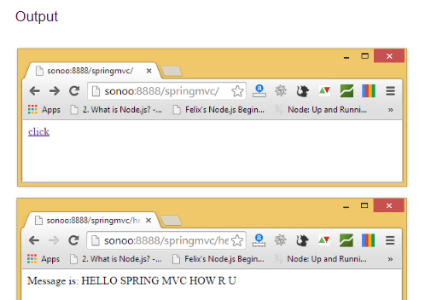
3. Ms🡺Note I can have n no of classes annotated with @Controller annotation in my spring app and invocation of the required controller class depends on URL(@RequestMapping).
4. Note spring has its own tag as in struts🡺later
5. MVC based form, file upload pagination🡺 examples later
6. Spring MVC tiles🡺 examples later

# **Spring and JAXB Integration Example**

1. JAXB is an acronym for **Java Architecture for XML Binding**. It allows java developers to map Java class to XML representation. JAXB can be used to **marshal** java objects into XML and vice-versa.
2. **It is an OXM (Object XML Mapping) or O/M framework provided by Sun.**
3. **Advantage of JAXB 🡺No need to create or use a SAX or DOM parser and write callback methods.**
4. Example🡺 to run this app we needed some jar files.

* **@XmlRootElement** It specifies the root element for the xml file.
* **@XmlAttribute** It specifies attribute for the property.
* **@XmlElement** It specifies the element.

1. 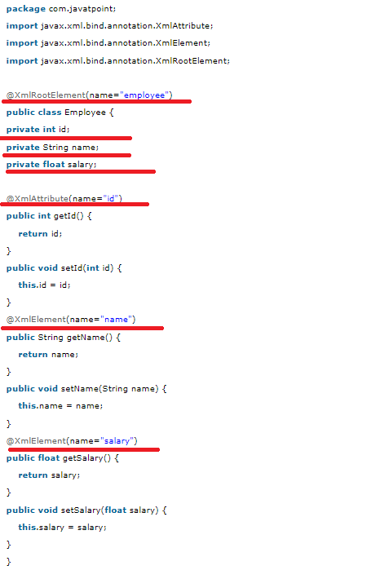
2. applicationContext.xml🡺 **NOTE HAVE WE USED THIS oxm ENTRY IN OUR NotifyBondline ?**

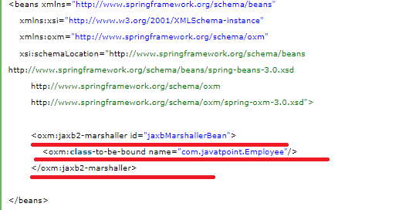

1. Client Application🡺 to set the values

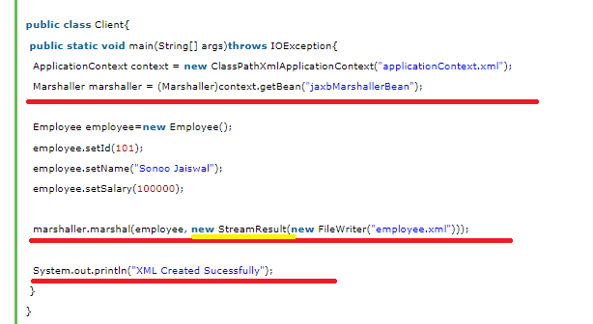

1. Output 🡺 **see the attribute id is added on root element, what is the syntax if I wanted to add the attribute to the Salary (child element of employee)**

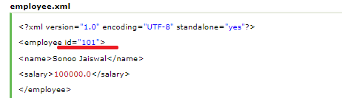

# **Dependency Injection with Factory Method in Spring**

1. Spring framework provides facility to inject bean using factory method. To do so, we can use two attributes of bean element.

* **factory-method:** represents the factory method that will be invoked to inject the bean.
* **factory-bean:** represents the reference of the bean by which factory method will be invoked. It is used if factory method is non-static.

1. 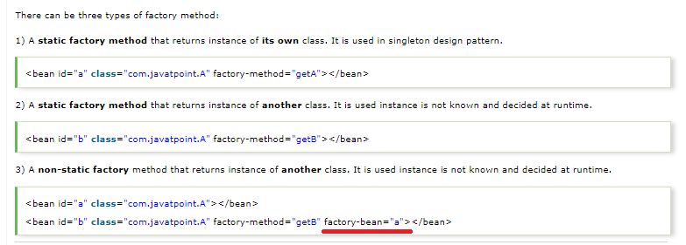

Explanation🡺

1. Type I 🡺 in this case instance of same class ,

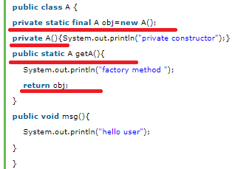

1. Xml🡺 above
2. Test class🡺

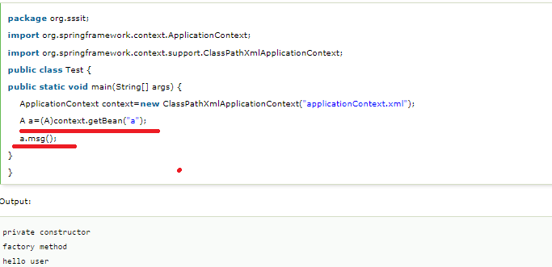

1. Type 2🡺

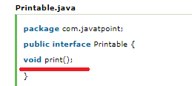

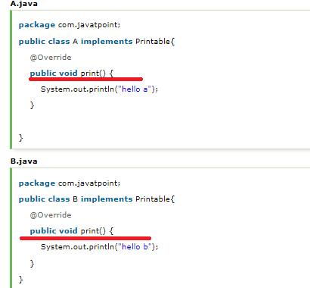

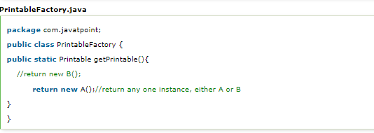

XML🡺 

Test Class🡺 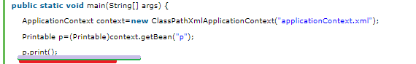

1. Type 3 🡺 Class A, b are same only one difference in PrintableFactory class is method is not static

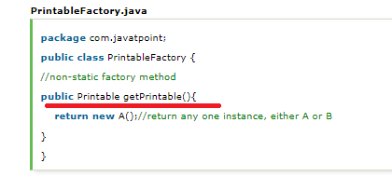

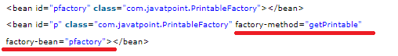

Hibernate

1. 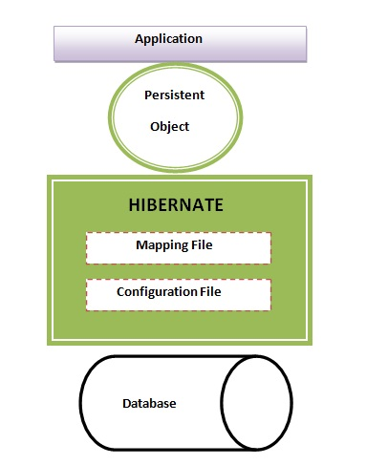
2. 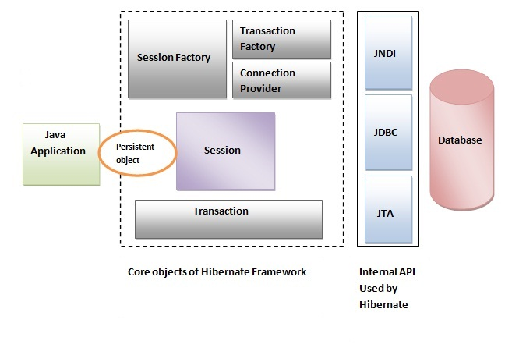
3. 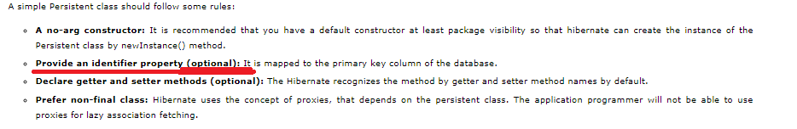

#### **employee.hbm.xml**

1. **id**It is the subelement of class. It specifies the primary key attribute in the class.
2. **generator** It is the subelement of id. It is used to generate the primary key. There are many generator classes such as assigned (It is used if id is specified by the user), increment, hilo, sequence, native etc. We will learn all the generator classes later.
3. Hibernate framework provides many built-in generator classes: **🡺**

* assigned
* increment
* sequence
* hilo
* native
* identity
* seqhilo
* uuid
* guid
* select
* foreign
* sequence-identity

1. **property** It is the subelement of class that specifies the property name of the Persistent class.
2. Hibernate Annotations are based on the JPA 2 specification and supports all the features.
3. **The core advantage of using hibernate annotation is that you don't need to create mapping (hbm) file. Here, hibernate annotations are used to provide the meta data. 🡺**open the hibernate.cgf.xml file, and add an entry of mapping resource like this: 🡺
4. Web application with hibernate🡺 not needed now, as w.k.t or see that after Seeing JSP
5. SessionFactory sf = new Configuration().configure(“Customized Hibernate config file name”).buildSessionFactory()
6. Methods of SessionFactory
7. getCurrentSession()
8. openSession()
9. close()
10. isClosed()
11. Methods of Session
12. Save
13. Get
14. Load🡺 will throw ObjectNotFoundException if the obj not found for the passed primary key
15. getSessionFatory
16. update
17. delete
18. clear
19. clearQuery
20. cancelQuery
21. createQuery
22. createSqlQuery
23. saveOrUpdate
24. merge
25. getNamedQuery
26. getNativeNamedQuery
27. contains
28. flush
29. beginTransaction
30. getTransaction().commit()/rollback
31. evict
32. Methods of Query🡺
33. setFirstResult
34. setMaxResult
35. setter(---------)
36. getResultList()
37. getSingleResult()🡺 throws NoResultException in case of no records found
38. list()
39. hibernate.hfg.xml🡺 file

<hibernate-configuration>

<session-factory>

<property name =” hibernate.connection.driverclass” value=””/>

<property name =” hibernate.connection.url” value=””/>

<property name =” hibernate.connection.pwd” value=””/>

<property name =” hibernate.connection.username” value=””/>

<property name =” hibernate.connection.poolsize” value=””/>

<property name =”showSQl” value=””/>

<property name =”formatsql” value=””/>

<property name =”cache.use_second_level_cache” value=”true”/>

<property name =”cache.provider_class” value=”true”/>

<property name =”formatsql” value=””/>

<property name =”hbm2ddl-auto” value=”create/update/validate/create-drop”/>

<mapping class=”fully classified name ” or resource=”employee.hbm.xml”

</session-factory>

1. hbm.xml file

<hibernate-mapping>

<class name =”fully qualified class name” table =”table name”>

<property name =”” column =”” type=””/>

<id name =”” column =”” type=””>

<generator class=””/>

</id>

</class>

</hibernate-mapping>

1. new Configuration().addClass(“pojo class name which have to be persisted”)
2. new Configuration().addResource(“----hbm.xml”)
3. new Configuration().setProperties(“name”, “value”)
4. List of Annotations
5. @Entity
6. @Table
7. @Column🡺 nullable, unique, length
8. @basic
9. @Lob
10. @Transient
11. @Temporal(TemporalType.time/date/timestamp)
12. @Id
13. @GeneratedValues(strategy= GenerationType.auto/sequence/unique/table)
14. @EmbeddedId
15. @Embeddable
16. @Embedded
17. @AttributeOverride(name = “attribute name” , column =@Column())
18. @AttributeOverrides({})
19. @ElementCollection(Fetch=FetchType.Lazy/Eager)🡺 by default its lazy and collection obj is fetched only on calling of getters ,suppose if getter is called after closing the session we get LagzInitializationException
20. @CollectionId(name =”**@Column**()”, generator=”**name1”**, type =”@type(type=”long”))
21. @GenericGenerator(name=” **name1**”, strategy=”hilo”)
22. @OneToOne🡺 mappedby
23. @OneToMany(cascade=CascadeType.All/Persist/detach/refresh/remove)🡺TransientObjectException
24. @ManyToOne
25. @ManyToMany
26. @NotFound(action=”NotFoundAction.Ignore)
27. @Inheritance(stratergy=Inheritance_type.SINGLE_TABLE/TABLE_PER_CLASS/JOINED_TABLE🡺 on parent class
28. @DiscriminatorColumn(name =””, type= dIscriminatorType.String)🡺 on parent class
29. @DiscriminatorValue(“”)
30. States of an object in hibernate
31. transient
32. Persistent
33. Detached
34. @NamedQuery
35. @NamedNativeQuery
36. @Cacheable
37. @Cache(use=ConcurrencyStrategy.READ_ONLY/READ_AND_WRITE/NON_STRICT_READ_AND_WRITE_TRANSACTIONAL
38. SequenceGenerator
39. SecondaryTable

Few information on Mappedby in hibernate from Stack overflow

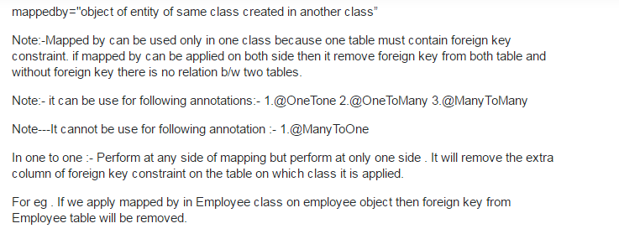

An example on Mappedby 🡺 see here in the mappedBy property has CLASS NAME AS THE VALUE

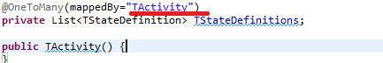

JPA

1. JPA is an api(classes and interface) to persistently store the vast amount of data into DB
2. JPA is by Oracle🡺 in the above notes I had saw that its sun specification(oracle now had acquired sun)
3. While Introducing EJB 3.0 the persistence layer was separated and specified as JPA 1.0
4. JPA 2.1 in 2013
5. Has EMF, EM ,E, ETransaction, Query, Persistence
6. Persistence🡺 this class contains static method to obtain EMF
7. EM and ET has one to one relationship
8. ORM takes care of Converting data from Object type to relational type and Vice versa
9. Mapping.xml🡺

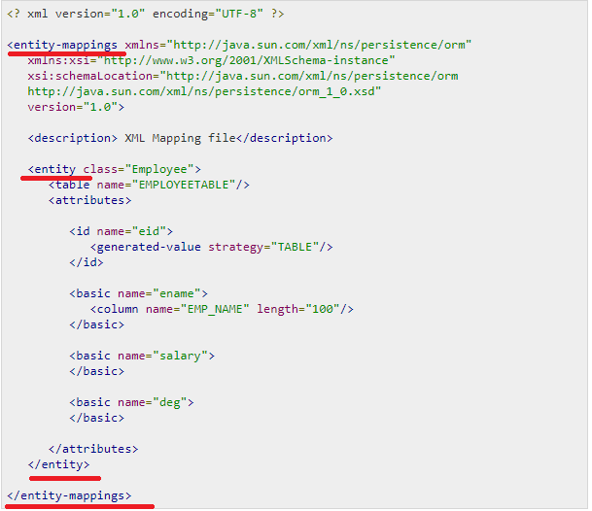

1. List of Annotations
2. @SequenceGenerator
3. @TableGenerator
4. @UniqueConstraint
5. Bean Conversion 🡺should gave getters for non-Boolean Property and must have isEmpty() for boolean properties
6. Persistence.xml

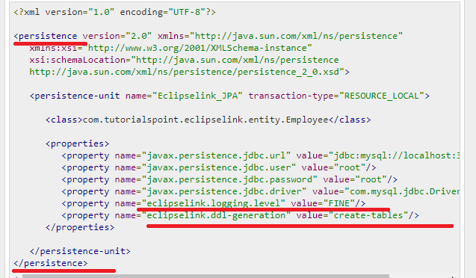

An example of how to create an annotation



1. EntityManagerFactory emfactory = Persistence.createEntityManagerFactory( "Eclipselink_JPA" );
2. CRUD methods 🡺 ms
3. Persist
4. Find
5. Remove
6. Update
7. 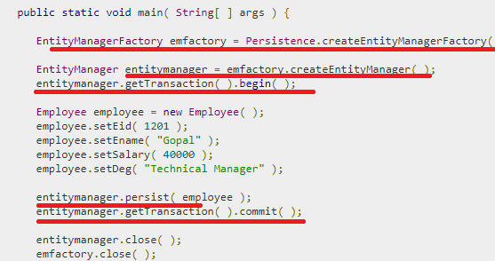
8. CQ is Type-safe
9. 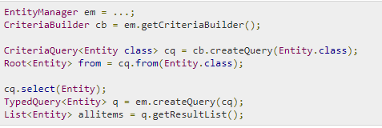

METHODS OF EM🡺 ESPECIALLY I WANTED TO KNOW THE TYPE OF QUERIES CREATED BY EM

JPA Documentation

1. **Needed an Example on Arrays storage**
2. **Map Was not covered in Collections Section**
3. Bean Validation

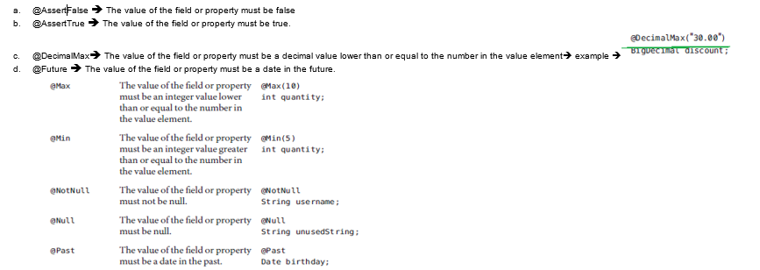

1. @Pattern and @Size🡺
2. **Example on primary key as Date field**
3. Caccade_type.All/Detach/Merge/persist/refresh/remove
4. Abstract entities🡺 an abstract class annotated with @Entity. Abstract entities are like concrete entities but cannot be instantiated.
5. Mapped superclass🡺 Entities may inherit from super classes that contain persistent state and mapping information but are not entities. That is, the superclass is not decorated with the @Entity annotation and is not mapped as an entity by the Java Persistence provider.

Example🡺 Parent 

Child🡺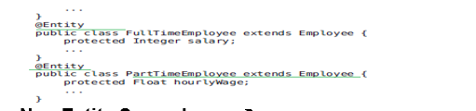

1. @SecondaryTable🡺
2. MetaModel🡺 MS🡺CriteriaQuery uses metamodel to create query
3. **Metamodel classes model an entity’s attributes and are used by Criteria queries to navigate to an entity’s attributes**
4. Automatic table generation inJPA

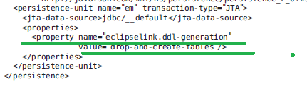

1. An Equivalent Meta model class for every entity gets generated at ,**compile time🡺 in maven I think during maven install on JPA project**
2. Syntax🡺

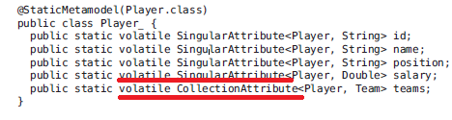

1. The **EntityManager.createQuery and EntityManager.createNamedQuery** methods are used to query the data store by using Java Persistence query language queries
2. Syntax🡺 same as in hibernate, in case of createQuery(“Sql Query is sent as input)

And in case of createNamedQuery(Name of the Query is sent as input);

1. Same as in hibernate JPA aslo has Positional parameter prefixed with “ ?Position number” and Named parameter which is prefixed with “**:**parameter_name”
2. Needed more information on
3. MEMBER OF
4. EXISTS
5. NOT EXISTS🡺 Scenarios
6. NEEDED MORE INFORMATION ON CASE EXAMPLE(AND ALSO IN PLSQL)
7. Set of Functions🡺 see later
8. **Constructor expressions allow you to return Java instances that store a query result element instead of an Object [].**

**Example🡺**



NOTE 🡺 ms 🡺**CriteriaQuery has methods like, select, from, where, having, groupBy and orderBy**

1. **Metamodel classes are typically generated by annotation processors either at development time or at runtime**
2. One of the programmatic way of getting metaModel class is🡺

object_OF_Root.getModel:

we can also get from em as shown below

**EntityType<Employee>Employee_=em.getMetamodel().entity(Employee.class)**

1. For more information On CQ and CB methods First see the Notes
2. Ms🡺CriteriaBuilder methods is returning Predicate
3. **NEEDED MORE INFORMATION ON PREDICATE AND EXPRESSION IN JPA**
4. Methods of CriteriaBuilder,
   1. and🡺 return type is Predicate
   2. asc🡺Order
   3. des🡺Order
   4. avg🡺Expression
   5. sum🡺
   6. Count🡺Expression
   7. concat🡺 Expression
   8. between🡺Predicate
   9. equal🡺Predicate
   10. equals🡺Boolean object
   11. exists🡺P
   12. ge()🡺P
   13. greaterThan🡺P
   14. greaterThanOrEqualTo🡺p
   15. greatest🡺P
   16. gt()🡺P, lt
   17. in
   18. isEmpty()🡺P
   19. isnotEmpty
   20. isFalse🡺P
   21. isMember🡺P
   22. isNotMember
   23. like
   24. min
   25. max
   26. not
   27. notEqual
   28. notLike
   29. length
5. Methods of the Root<T> is🡺 ms actually root refers to “from” part of the SQL query
   1. get(field_name)
   2. fetch(field_name)
   3. in()
   4. isNull
   5. isNotNull
   6. join()
   7. joinCollection
   8. joinList
   9. joinMap
   10. joinSet

Core Java

Enum

1. Example🡺

Public enum Week implements Serializable{

SUNDAY(“sun”, “First Day of the Week),

MONDAY(“mon”, “second Day of the Week),

TUESDAY(“tues”, “third Day of the Week),

WEDNESDAY(“wed”, “fourth Day of the Week),

THURSDAY(“thurs”, “fifth Day of the Week),

FRIDAY(“fri”, “sixth Day of the Week),

SATURDAY(“sat”, “seventh Day of the Week),

Private String code;

Private String description;

Private Week(String cd, String des){

this. code= cd;

this. description= des;

}

Public getcode(){

return code;

}

Public getdescription(){

return description;

}

}

Out the class calling an enum syntax is🡺

String codeFromEnum=Week.SUNDAY.getCode();

String descriptionFromEnum=Week.SUNDAY. getdescription();

1. Enum is used to hold set of predefined values or constant values
2. Implicitly enum constants are static final
3. By default enum will have private constructor
4. Enum can be inside or outside class also.
5. enum improves type safety
6. enum can be easily used in switch
7. enum can have fields, constructors and methods🡺 example see above
8. **enum may implement many interfaces but cannot extend any class because it internally extends Enum class**
9. The java compiler internally adds the values() method when it creates an enum. The values() method returns an array containing all the values of the enum.

Example🡺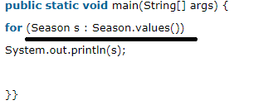

1. **we can initialize the specific value to the enum constants by defining fields and constructors🡺 as shown in above example**
2. 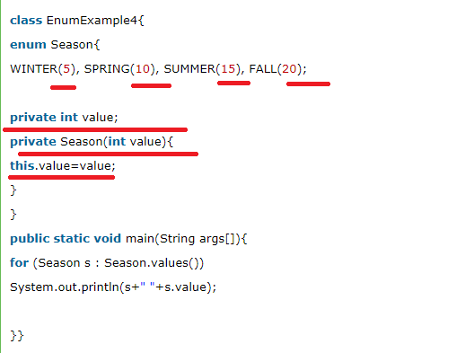

Ms🡺See as shown in the above code🡺 will creating the enum only we are giving its value, and we are not passing any values from outside

1. **Can we create the instance of enum by new keyword? 🡺 No, because it contains private constructors only.**

|  |
| --- |
|  |

Java-Printout

1. **Object-oriented🡺 means we organize our software as a combination of different types of object that has both data and behavior**
2. **OOPS🡺 is a methodology that simplify software development and maintenance by providing some rules**
3. JDK🡺JRE+ debugger+ COMPILER
4. Jre🡺jvm + set of libraries
5. JVM🡺 ms where my app enters and gets executed
6. Data Types🡺 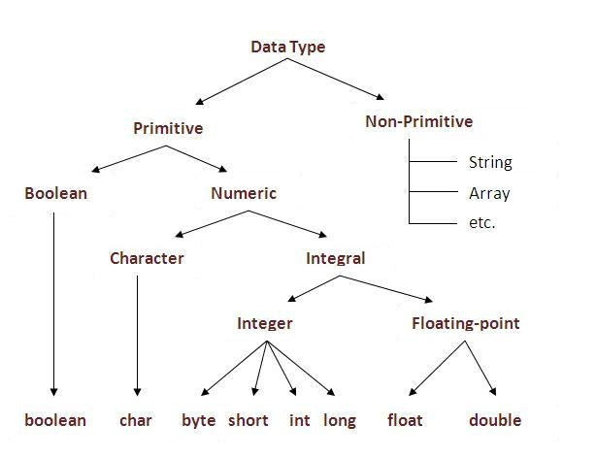
7. Labelled for loop🡺 needed example on this
8. **Polymorphism🡺 one task is performed in different ways**
9. Encapsulation🡺 Binding or wrapping the code and data together is called encapsulation

JAVA BEAN is fully encapsulated

1. **Needed example on newInstance() method for object creating in java**
2. why the constructor has name Constructor🡺 it constructs the values i.e. provides data for the object
3. Aggregation purpose is reusability
4. **I had observed that Javac places IIB inside each constructor of Child but not in the parent constructor.**
5. Use instanceOf operator to avoid ClassCastException at run time(if both the classes does not have **“is-a”** relationship means we will get class cast exception at run time).
6. Static import🡺advantage🡺 helps in less coding
7. **See Qspider notes for more information on System.out.println()**
8. Primitive type into its equivalent Wrapper types is called boxing
9. Methods of object class
10. hashCode()
11. equals()
12. clone()🡺throws CloneNotSupportedException
13. toString
14. notify
15. notifyAll
16. wait🡺InterruptedException
17. finalize
18. datatype[] arrayname= new datatype[size]; 🡺or 🡺int[] arrayname ={1,2,3}
19. array has length property
20. In java, array is an object. For array object, an proxy class is created whose name can be obtained by getClass().getName() method on the object.
21. We can copy an array to another by the arraycopy method of System class. 🡺

Example

**public** **static** **void** arraycopy(

Object src, **int** srcPosfromwheretocopy,Object dest, **int** destPoswheretoPaste, **int** length

)

1. Wrapper🡺
2. valueOf()🡺 to convert primitive to object type and its static method
3. xxxValue🡺 to convert object type to primitive and its instance method🡺 example intValue()
4. 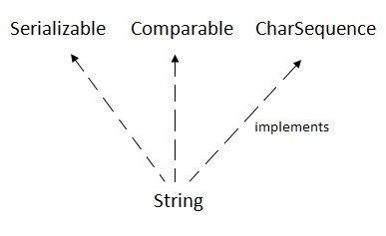 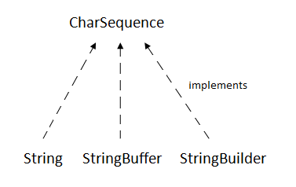
5. Methods of String class
6. [char charAt(int index)](https://www.javatpoint.com/java-string-charat)
7. [int length()](https://www.javatpoint.com/java-string-length)
8. [static String format(String format, Object... args)](https://www.javatpoint.com/java-string-format)
9. [String substring(int beginIndex)](https://www.javatpoint.com/java-string-substring), [String substring(int beginIndex, int endIndex)](https://www.javatpoint.com/java-string-substring)
10. [boolean contains(CharSequence s)](https://www.javatpoint.com/java-string-contains)
11. [static String join(CharSequence delimiter, CharSequence... elements](https://www.javatpoint.com/java-string-join))

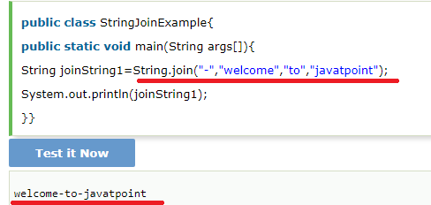

1. [boolean equals(Object another)](https://www.javatpoint.com/java-string-equals)
2. [static String equalsIgnoreCase(String another)](https://www.javatpoint.com/java-string-equalsignorecase)
3. [boolean isEmpty()](https://www.javatpoint.com/java-string-isempty)
4. [String concat(String str)](https://www.javatpoint.com/java-string-concat)
5. [String replace(char old, char new)](https://www.javatpoint.com/java-string-replace), [String replace(CharSequence old, CharSequence new)](https://www.javatpoint.com/java-string-replace)
6. [String[] split(String regex)](https://www.javatpoint.com/java-string-split)
7. [int indexOf(int ch)](https://www.javatpoint.com/java-string-indexof), [int indexOf(int ch, int fromIndex)](https://www.javatpoint.com/java-string-indexof), [int indexOf(String substring)](https://www.javatpoint.com/java-string-indexof), [int indexOf(String substring, int fromIndex)](https://www.javatpoint.com/java-string-indexof)
8. [String toLowerCase()](https://www.javatpoint.com/java-string-tolowercase),[String toUpperCase()](https://www.javatpoint.com/java-string-touppercase)
9. [String trim()](https://www.javatpoint.com/java-string-trim)
10. [static String valueOf(int value](https://www.javatpoint.com/java-string-valueof))
11. Needed few information on StringTokenizer
12. Methods of StringBuffer
13. append(String s)🡺Synchronized
14. insert(int offset, String s)🡺 Synchronized
15. replace(int startIndex, int endIndex, String str)🡺 Synchronized
16. delete(int startIndex, int endIndex)🡺 Synchronized
17. reverse()🡺Synchronized
18. and few String methods on StringBuffer🡺

* capacity(),
* ensureCapacity(int minCapacity)
* charAt(int index)
* length()
* substring

1. 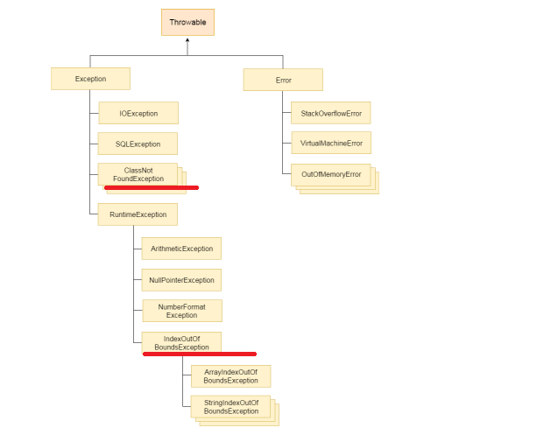

**Needed more information on ClassNotFoundException and ClassDefException**

1. CheckedException, unCheckedException and errors
2. Checked Exception🡺 should be handled using try-catch block or throws keyword
3. **Suppose if method does not throw Checked Exception then I cannot simply Throw it either by using Throws or throw🡺 ms 🡺 check this again**
4. I cannot throw Checked exception using throw keyword🡺ms
5. No statements between try-catch-finally🡺 it will become unreachable
6. Throw keyword is mainly used to throw custom Exceptions
7. The Java throw keyword is used to explicitly throw an exception.

# **Java Exception propagation**

#### Rule: By default Unchecked Exceptions are forwarded in calling chain (propagated).

#### **Rule: By default, Checked Exceptions are not forwarded in calling chain (propagated).**

Example for above rule is,

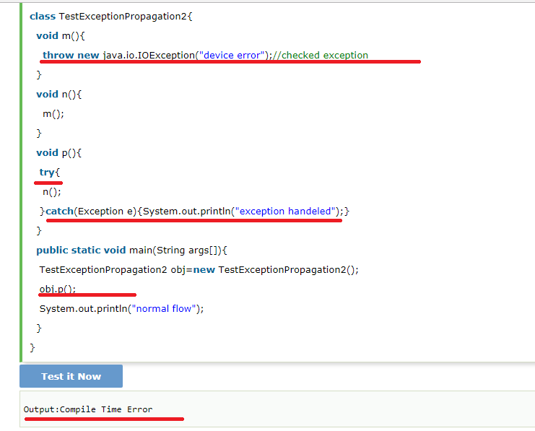

### Rule: If you are calling a method that declares an exception, you must either caught or declare the exception.

1. Lets see the above rule🡺

There are two cases:

1. **Case1:**You caught the exception i.e. handle the exception using try/catch.
2. **Case2:**You declare the exception i.e. specifying throws with the method.

# **Java Inner Classes**

1. 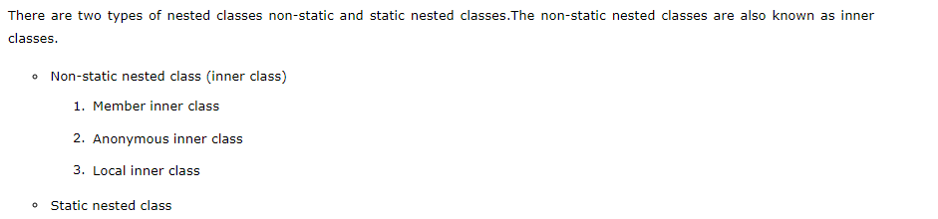
2. A non-static class that is created inside a class but outside a method is called member inner class. 🡺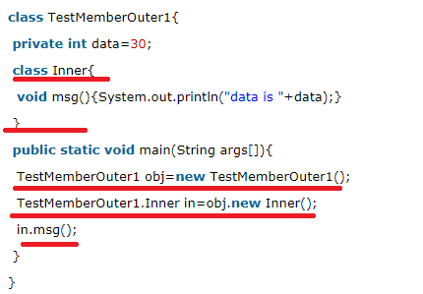
3. A class that have no name is known as anonymous inner class in java. It should be used if you have to override method of class or interface. Java Anonymous inner class can be created by two ways: 🡺Interface, abstract Class
4. 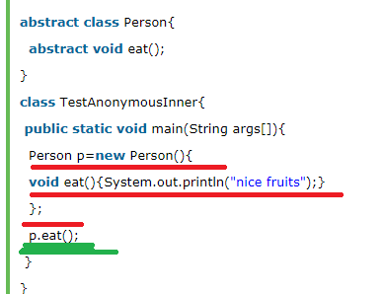
5. A class i.e. created inside a method is called local inner class in java. If you want to invoke the methods of local inner class, you must instantiate this class inside the method.
6. 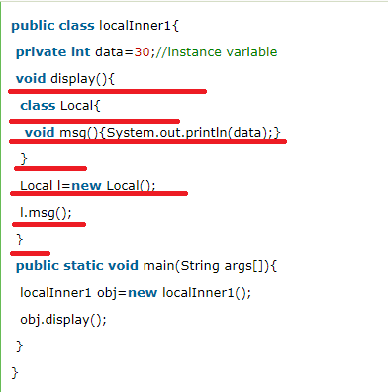
7. Rules for LIC🡺

#### Rule: Local variable can't be private, public or protected.

#### 1) Local inner class cannot be invoked from outside the method.

#### 2) Local inner class cannot access non-final local variable till JDK 1.7. Since JDK 1.8, it is possible to access the non-final local variable in local inner class.

1. Static Nested classes
   1. A static class i.e. created inside a class is called static nested class in java. It cannot access non-static data members and methods. It can be accessed by outer class name. 🡺 **Then how does non static members of outer class is accessed inside the inner class? 🡺 ms it cant access non static members directly , so needed to see how it creates oby and access its outer class non static variables**
   2. 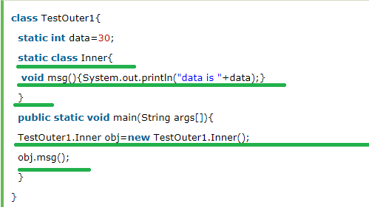

Explanation🡺

* see static inner class has non static method
* **Syntax to call static inner class static method🡺  TestOuter2.Inner.msg();**

Java_PrintOut1

1. Thread is a light weight **sub process**, a smallest unit of processing
2. On calling start() Thread moves from new to runnable state
3. Methods of thread class
   * 1. **run()**
     2. **start**
     3. **sleep(long miliseconds)🡺static**
     4. **join(),join(long miliseconds)🡺** The join() method waits for a thread to die. In other words, it causes the currently running threads to stop executing until the thread it joins with completes its task.

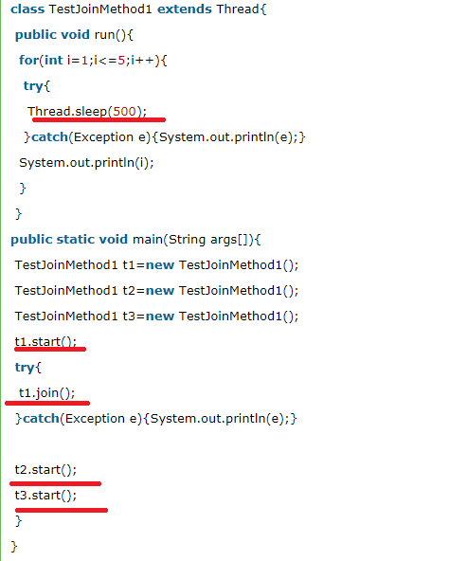

**Incase of join(milliseconds)🡺for the specified milliseconds thread will not release the resource🡺 example🡺** when t1 is completes its task for 1500 miliseconds(3 times) then t2 and t3 starts executing.

* + 1. **yield()🡺 what is the difference between join() and yield()?**
    2. **getPriority(),setPriority()**
    3. **getName(),setName(String name)**
    4. **Thread currentThread()🡺static**
    5. **getId()**
    6. **public Thread.State getState() 🡺 returns the state of the thread**
    7. **isAlive():**
    8. **isDaemon,** **setDaemon**
    9. **holdsLock()**
    10. **interrupt, isInterrupted,** **interrupted**
    11. **suspend, resume** ,**stop🡺 all are deprecated**

1. **Thread scheduler** in java is the part of the JVM that decides which thread should run.
2. There is no guarantee that which runnable thread will be chosen to run by the thread scheduler.
3. No. After starting a thread, it can never be started again. If you does so, an IllegalThreadStateException is thrown
4. If you sleep a thread for the specified time, the thread scheduler picks up another thread and so on
5. By default each thread has a name i.e. thread-o, thread-1 and so on
6. Make a user thread daemon thread before its started otherwise we will get IllegalThreadStateException
7. **Thread Group, Thread Pool, Java Shutdown hook**
8. GC is a process of reclaiming runtime unused memory or is a process of destroying the unused obj

#### Note: The Garbage collector of JVM collects only those objects that are created by new keyword. So if you have created any object without new, you can use finalize method to perform cleanup processing (destroying remaining objects).

1. The gc() is found in System and Runtime classes.

#### Note: Garbage collection is performed by a daemon thread called Garbage Collector(GC). This thread calls the finalize() method before object is garbage collected.

#### Note: Neither finalization nor garbage collection is guaranteed.

1. **Java Runtime** class is used to interact with java runtime environment
2. **Methods of Runtime,**
   1. static Runtime getRuntime()
   2. exit(int status)
   3. availableProcessors()
   4. freeMemory()
   5. totalMemory()
   6. public Process exec(String command)throws IOException 🡺 executes given command in a separate process.

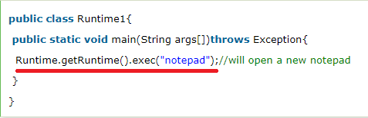

## **How to shutdown system in Java using exec()**

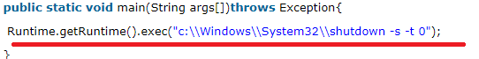

## **restart 🡺** Runtime.getRuntime().exec("shutdown -r -t 0");

1. 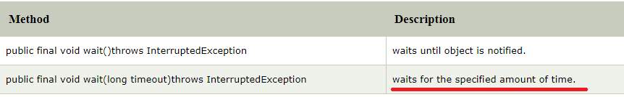
2. If any thread is in sleeping or waiting state (i.e. sleep() or wait() is invoked), calling the interrupt() method on the thread, breaks out the sleeping or waiting state throwing InterruptedException.

JDBC

1. 4 types of driver🡺

* JDBC-ODBC bridge driver
* Native-API driver (partially java driver)
* Network Protocol driver (fully java driver)
* Thin driver (fully java driver)

1. 5 Steps in connecting java app to db
   1. Register the driver
   2. Create connection
   3. Create statement
   4. Execute query
   5. Close connection🡺by closing the connection obj Statement and ResultSet will be closed automatically

Java_PrintOut2

1. The forName() method of Class class is used to register the driver class🡺 Class.forName("oracle.jdbc.driver.OracleDriver");  🡺
2. Methods of DriverManager class

* registerDriver(Driver driver):
* deregisterDriver(Driver driver):
* getConnection(String url):🡺  static
* static Connection getConnection(String url,String userName,String password):

1. Connection interface Methods,
   * 1. **createStatement**
     2. **setAutoCommit()**
     3. **commit**
     4. **rollback**

**By default, connection commits the changes after executing queries**

1. Statement methods,
2. **ResultSet executeQuery(String sql)**
3. **int executeUpdate(String sql)**
4. **boolean execute(String sql):**
5. **int[] executeBatch()**
6. Initially ResultSet maintains cursor to first row, methods of ResultSet

#### By default, ResultSet object can be moved forward only and it is not updatable.

1. **boolean next():**
2. **boolean previous():**
3. **boolean first()**
4. **boolean last()**
5. **int getInt(int columnIndex)**
6. **int getInt(String columnName):**
7. **String getString(int columnIndex):**
8. **public String getString(String columnName):**
9. Methods of PreparedStatement
10. setInt(int paramIndex, int value)
11. setString(int paramIndex, String value)
12. setFloat(int paramIndex, float value)
13. setDouble(int paramIndex, double value)
14. int executeUpdate()
15. ResultSet executeQuery()
16. The metadata means data about data
17. ResultSetMetaData methods,
18. int getColumnCount()throws SQLException
19. String getColumnName(int index)throws SQLException
20. String getColumnTypeName(int index)throws SQLException
21. public String getTableName(int index)throws SQLException
22. DatabaseMetaData interface methods,
23. **String getDriverName()throws SQLException**
24. **String getDriverVersion()throws SQLException:**
25. **String getUserName()throws SQLException:**
26. **String getDatabaseProductName()throws SQLException:**
27. **String getDatabaseProductVersion()throws SQLException:**
28. **public ResultSet getTables(String catalog, String schemaPattern, String tableNamePattern, String[] types)throws SQLException**

Java_PrintOur3

Collection

1. hierarchy of collection framework
2. Methods of Collection interface
3. boolean add(Object element)
4. boolean addAll(Collection c)
5. boolean remove(Object element)
6. boolean removeAll(Collection c)
7. boolean retainAll(Collection c)
8. boolean contains(Object element)
9. boolean containsAll(Collection c)
10. int size()
11. clear()
12. Iterator iterator()
13. Object[] toArray()🡺 Needed to do hands on this
14. boolean isEmpty()
15. boolean equals(Object element)
16. int hashCode()
17. Methods of Iterator interface,
18. boolean hasNext()
19. Object next()🡺 in case of ResultSet it’s of boolean type
20. void remove()
21. Methods of Iterator interface
22. Boolean hasPreviuos
23. Object previous
24. above methods
25. Methods of ArrayList
26. **void** add(int index, Object element)🡺 in case of Collection return type was boolean(no no see below method)
27. boolean add(Object o)
28. int indexOf(Object o)
29. int lastIndexOf(Object o)
30. boolean addAll(Collection c)
31. boolean addAll(int index, Collection c)
32. clear()
33. Object[] toArray()
34. **void trimToSize()🡺It is used to trim the capacity of this ArrayList instance to be the list's current size.**
35. Methods of List Interface
36. Add(posi, element)
37. addAll(posi, Collection obj)
38. get(position)
39. set(position, element)
40. remove(position)
41. ListIterator listIterator()
42. Linked list methods,
43. addFirst(Object o)
44. addLast(Object o)
45. Object getFirst()
46. Object getLast()
47. And all above methods of ArrayList +linked List(ms)
48. Methods of HashSet
49. boolean contains(Object o)🡺 It is used to return true if this set contains the specified element.==> Set has this method instead of Get(posi) as Set does not have key or index to get the element based on key or index.
50. Methods of TreeSet,
51. Object first()🡺It is used to return the first (lowest) element currently in this sorted set.
52. Object last() 🡺 It is used to return the last (highest) element currently in this sorted set.
53. Methods of Queue,
54. boolean add(object)🡺 It is used to insert the specified element into this queue and return true upon success.
55. boolean offer(object)🡺 It is used to insert the specified element into this queue.
56. Object remove()🡺It is used to retrieves and removes the head of this queue 🡺 I think this throws some exception
57. Object poll()🡺It is used to retrieves and removes the head of this queue, or returns null if this queue is empty.
58. Object element()🡺It is used to retrieves, but does not remove, the head of this queue.
59. Object peek()🡺 It is used to retrieves, but does not remove, the head of this queue, or returns null if this queue is empty.

NOTE🡺 CLEAR DIFFERENCE BETWEEN THIS METHODS IS GIVEN SEE NOTES OR STACK OVERFLOW

1. [Java Deque & ArrayDeque](https://www.javatpoint.com/java-deque-arraydeque)🡺 LATER
2. Methods of Map
3. Object put(Object key, Object value)
4. void putAll(Map map)
5. Object remove(Object key)
6. Object get(Object key)
7. boolean containsKey(Object key)
8. Set keySet()
9. Set entrySet()
10. Ms🡺 Collection values()
11. Entry is the sub interface of Map. 🡺 methods are 🡺 Object getKey() and Object getValue()
12. HashMap🡺 it may have one null key and multiple null value. It contains only unique elements. it maintains no order.
13. Methods of HashMap🡺
14. boolean containsValue(Object value)
15. boolean isEmpty()
16. Collection values()🡺It is used to return a collection view of the values contained in this map.
17. LinkedHashMap🡺 It may have one null key and multiple null values. It contains only unique elements. **It is same as HashMap instead maintains insertion order.**
18. TreeMap cannot have null key but can have multiple null values.
19. Methods of TreeMap,
20. Object firstKey() 🡺 It is used to return the first (lowest) key currently in this sorted map.
21. Object lastKey()🡺It is used to return the last (highest) key currently in this sorted map.
22. Hashtable🡺 It may have not have any null key or value.
23. Methods of HashTable🡺
24. void rehash()It is used to increase the size of the hash table and rehashes all of its keys.

# Collections class🡺 has methods t Synchronize Collection,List, Set and Map and has the method to reverse(), and also has method to sort() a list

1. **Sorting a collection🡺 Comparable and Comparator interface🡺 needed to do hands on**
2. The java.util.Properties class is the subclass of Hashtable.
3. The Properties class provides methods to get data from properties file and store data into properties file.
4. Methods of Properties class
   1. 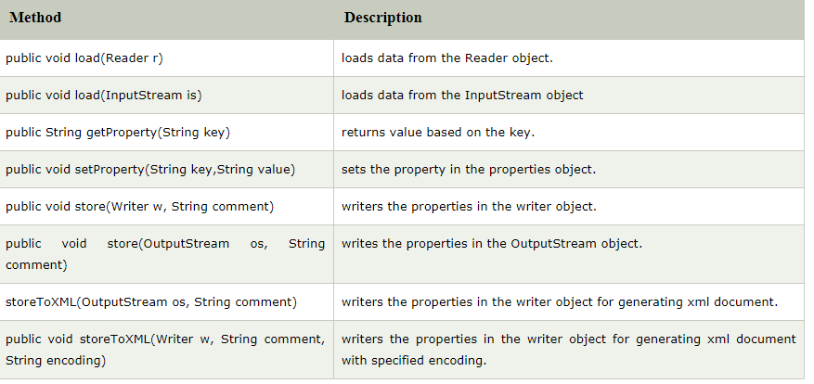
5. By System.getProperties() method we can get all the properties of system

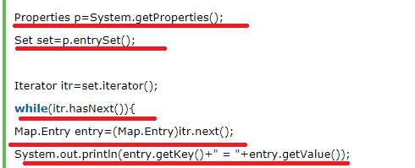

Java_PrintOut4

1. Java has Streams for Byte-orientation and Reader and Writer for Character-Orientation
2. OutputStream(is an abstract class and it’s the super class for all output stream class)🡺 for write and InputStream(is an abstract class and it’s the super class for all input stream class)🡺 do to read operation
3. OutputStream methods,
4. public void write(**int**)throws IOException
5. public void write(byte[])throws IOException
6. public void flush()throws IOException
7. public void close()throws IOException
8. Java output stream hierarchy
9. Java input stream hierarchy
10. FileOutputStream example🡺

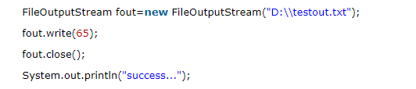

1. FileIntputStream example🡺

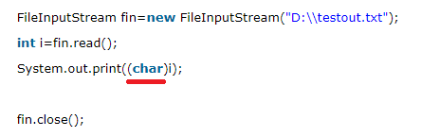

1. Java ByteArrayOutputStream class is used to **write common data** into multiple files, example,

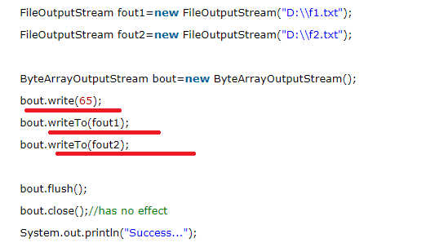

Ms🡺See here first content is written into BAOS by using write() and then writeTo() method is called to write into the files

1. Java SequenceInputStream class is used to read data from multiple streams. It reads data sequentially (one by one). Example🡺

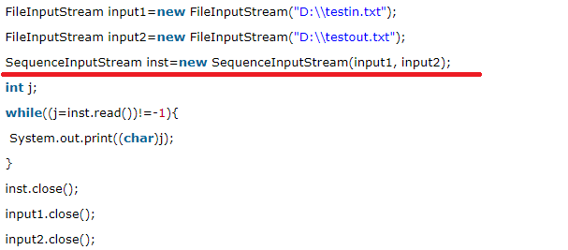

1. **Needed more information on Enumeration**
2. BufferedOutputSTrem🡺  it makes the performance fast.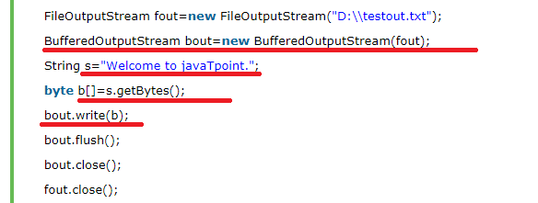
3. BufferedInputStream🡺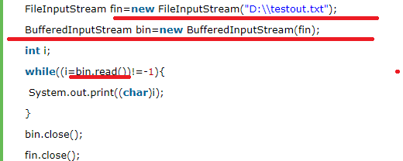
4. Reader and Writer🡺 needed hierarchy structure for this
5. Methods of Writer
6. append(char c), append(CharSequence csq), append(CharSequence csq, int start, int end)
7. write(char[] cbuf), write(int c), write(String str)
8. flush()
9. Reader methods🡺
10. read()
11. close()
12. reset()🡺It resets the stream.
13. skip(long n)🡺 It skips characters.
14. CharArrayWriter class can be used yto write data to multiple files
15. 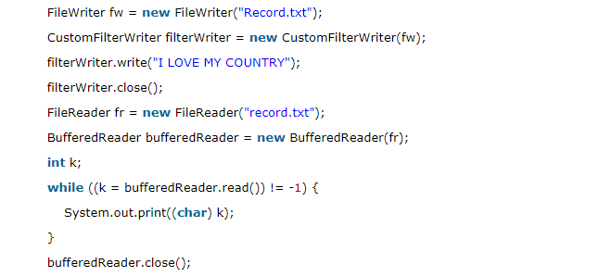

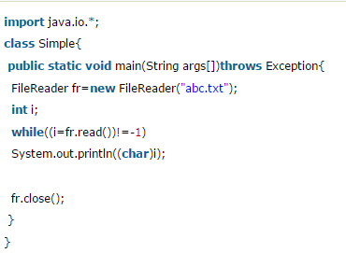

1. Reader example later

NOTE🡺 APART FROM THIS I HAVE OTHER STREAM AND READER CLASSES NEEDED TO COVER THOSE ALSO

Java PrrintOut5

1. Is the difference between Comparable and Comparator interface this we will see 🡺While doing hands on

Java PrintOut 6

1. 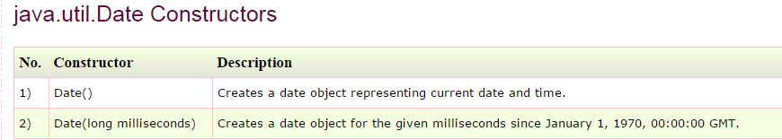
2. 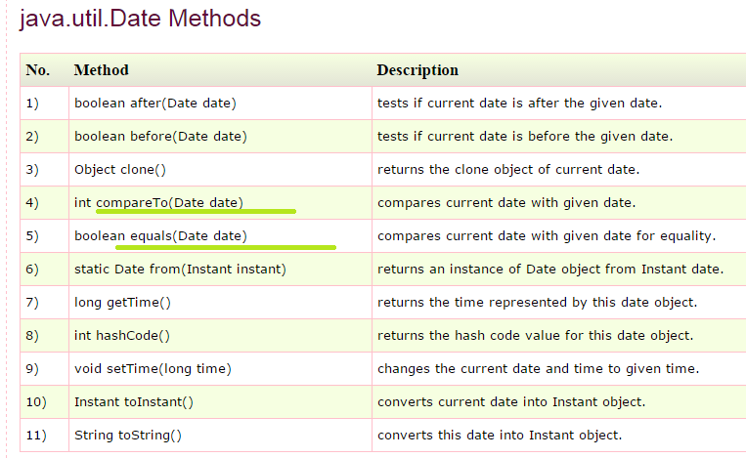
3. System.currentTimeMillis();
4. java.sql.Date methods🡺
5. java.util.Calendar Java Calendar class is an abstract (Java Calendar class is an abstract) methods,
6. abstract void add(int field, int amount)🡺 It is used to add or subtract the specified amount of time to the given calendar field, based on the calendar's rules.
7. **int get(int field)**
8. static Calendar getInstance()
9. **void set(int field, int value)**
10. void setTime(Date date)🡺 It is used to set this Calendar's time with the given Date.
11. Date getTime()🡺It is used to return a Date object representing this Calendar's time value.
12. Calendar class has lot of Properties/constant fields
13. **NEEDED TO KNOW HOW TO COMPARE DATE ARRAY AS ALREADY DATE CLASS IMPLEMENTS COMPARATOR**
14. **Collect few information on Constructor Chaining and Serialization🡺Qspider**

Core Java Interview Questions(Tpoint )

1. JIT compiles parts of the byte code that have similar functionality at the same time, and hence reduces the amount of time needed for compilation. Here the term “compiler” refers to a translator from the instruction set of a Java virtual machine (JVM) to the instruction set of a specific CPU.
2. delete,next,main,exit or null IS NOT A keyword in java
3. What is the purpose of default constructor 🡺The default constructor provides the default values to the objects. The java compiler creates a default constructor only if there is no constructor in the class
4. What if the static modifier is removed from the signature of the main method🡺 Program compiles. But at runtime throws an error "NoSuchMethodError".
5. **Yes, all functions in Java are virtual by default.**
6. Can you declare the main method as final🡺yes

### What is the base class for Error and Exception? 🡺Throwable.

Can a class have an interface?==> **Yes, it is known as nested interface.**

Can an Interface have a class? 🡺 **Yes, they are static implicitely.**

1. What kind of thread is the Garbage collector thread? 🡺 DAEMON thread

How will you invoke any external process in Java? **🡺** By Runtime.getRuntime().exec(?) method.

1. Serialization is a process of writing the state of an object into a byte stream.It is mainly used to travel object's state on the network.
2. **Deserialization is the process of reconstructing the object from the serialized state.It is the reverse operation of serialization.**
3. If you define any data member as transient,it will not be serialized
4. Reflection is the process of examining or modifying the runtime behaviour of a class at runtime.
5. **The purpose of the System class is to provide access to system resources.**
6. **Singleton Class Program🡺**
7. **The shutdown hook is basically a thread i.e. invoked implicitely before JVM shuts down. So we can use it perform clean up resource**
8. ADVANTAGE OF PROPERTY FILE 🡺If you change the value in properties file, you don't need to recompile the java class. So, it makes the application easy to manage.
9. **Two different keys with the same hash value is known as hash-collision. Two different entries will be kept in a single hash bucket to avoid the collision.**



Tutorials Point interview Questions

1. The String class is immutable, so that once it is created a String object cannot be changed
2. **Needed to Know more about Pattern matching in java**
3. **If you want to write a checked exception that is automatically enforced by the Handle or Declare Rule, you need to extend the Exception class**
4. **When Abstract methods are used?**

If you want a class to contain a particular method but you want the actual implementation of that method to be determined by child classes, you can declare the method in the parent class as abstract.

1. Comparable Interface🡺 is used for Sorting purpose
2. **Difference between throw and throws?**

It includes:

Throw is used to trigger an exception where as throws is used in declaration of exception.

Without throws, Checked exception cannot be handled where as checked exception can be propagated with throws.

1. JAR files is Java Archive files and **it aggregates many files into one.** It holds Java classes in a library. JAR files are built on ZIP file format and have .jar file extension.
2. WAR files🡺This is Web Archive File and used to store XML, java classes, and Java Server pages html, JS.
3. MS🡺 **We can only add private , protected and public to constructor**

Can I make a constructor as Synchronized? 🡺 no I get IllegalModifier in STS

1. **What are the ways in which a thread can enter the waiting state?**

**A thread can enter the waiting state by invoking its sleep() method, by blocking on IO, by unsuccessfully attempting to acquire an object's lock, or by invoking an object's wait() method. It can also enter the waiting state by invoking its (deprecated) suspend() method.**

1. What is the difference between yielding and sleeping?

When a task invokes its yield() method, it returns to the ready state. When a task invokes its sleep() method, it returns to the waiting state.

1. File class is used to create objects that provide access to the files and directories of a local file system.
2. **Which class should you use to obtain design information about an object?**

The Class class is used to obtain information about an object's design and java.lang.Class class instance represent classes, interfaces in a running Java application.

1. **Is there any limitation of using Inheritance?**

Yes, since inheritance inherits everything from the super class and interface, it may make the subclass too clustering and sometimes error-prone when dynamic overriding or dynamic overloading in some situation.

1. When copying elements between different arrays, if the source or destination arguments are not arrays or their types are not compatible, an **ArrayStoreException** will be thrown.
2. **Under what conditions is an object's finalize() method invoked by the garbage collector?**

The garbage collector invokes an object's finalize() method when it detects that the object has become unreachable.

1. The class ClassLoader is an abstract class.
2. Synchronized methods are methods that are used to control access to an object. A **synchronized statement** can only be executed after a thread has acquired the lock for the object or class referenced in the synchronized statement.
3. Ms🡺 Synchronized statements is Synchronized block
4. **Break statement can be used as labels in Java?**

Yes, an example can be *break one;*

1. **What is Nested top-level class?**

**If a class is declared within a class and specify the static modifier, the compiler treats the class just like any other top-level class. Nested top-level class is an Inner class.**

1. The size is the number of elements actually stored in the vector, while capacity is the maximum number of elements it can store at a given instance of time.
2. Path and Classpath are operating system level environment variables. Path is defines where the system can find the executables(.exe) files and classpath is used to specify the location of .class files.
3. **What is constructor chaining and how is it achieved in Java?**

A child object constructor always first needs to construct its parent. In Java it is done via an implicit call to the no-args constructor as the first statement.

Collections Interview Questions

1. 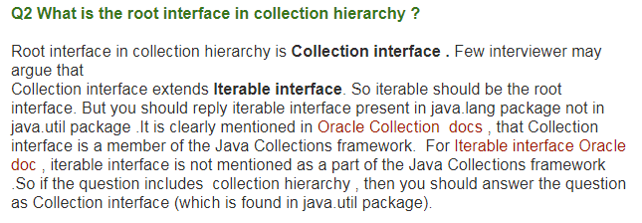
2. **Stack**, HashTable, Vector🡺 are synchronized
3. **Set is unordered and List maintains the insertion order**
4. 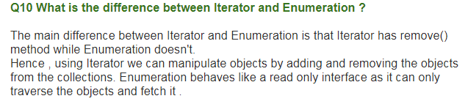
5. 
6. Queue🡺FIFO
7. Stack🡺FILO
8. 



1. 
2. 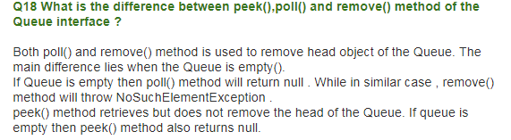
3. 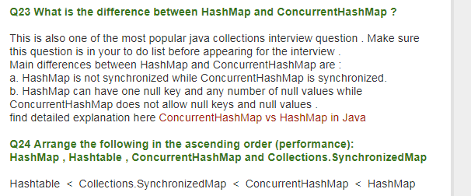
4. Working of the HashMap
5. 
6. 
7. 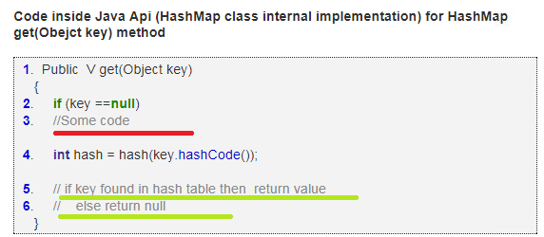
8. 
9. 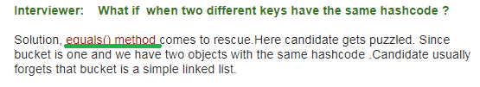
10. 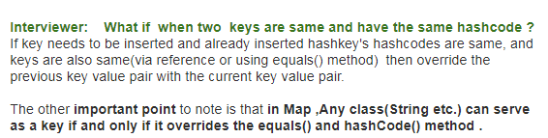
11. 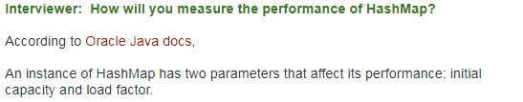

Where Capacity🡺

Load Factor🡺

1. 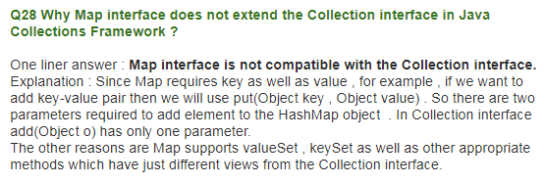

**NOTE🡺 BUT LIST IS ALSO HAVING INDEX BASED THEN WHAT IS THE DIFFERENCE BETWEEN KEY OF MAP AND INDEX OF LIST AS BOTH MAP HAS GET(KEY) AND LIST HAS GET(INDEX)**

1. Working of HashSet
2.  🡺 in case of duplication overriding will take place
3. 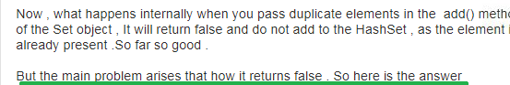
4. 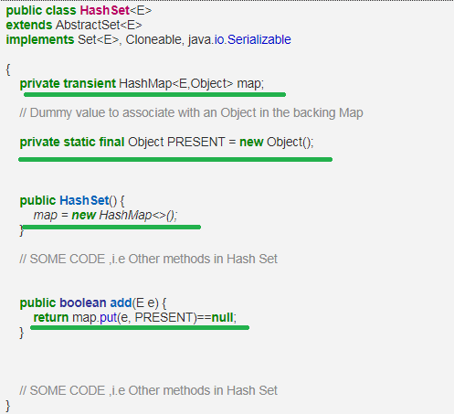
5. Thus in Set we achieve Uniqueness with the help of Map,
6. 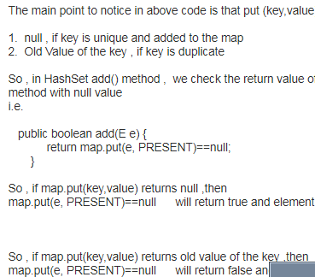
7. 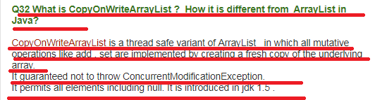
8. **Working of TreeMap in Java 🡺 Later**
9. **Working of ConcurrentHashMap in Java**
10. 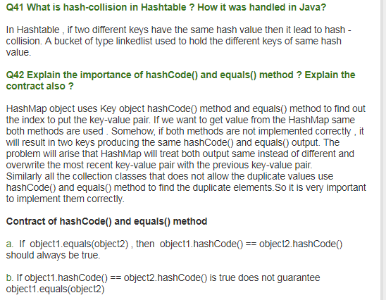
11. 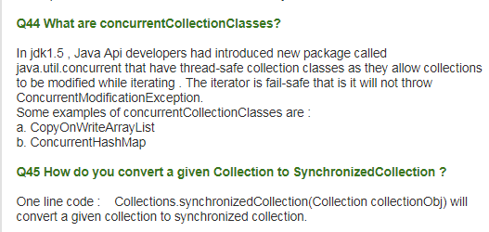
12. **IdentityHashMap and WeakHaskMap, EnumSet🡺Later**

NOTE🡺MS IN COLLECTIONS CLASS ALL METHODS ARE STATIC

1. 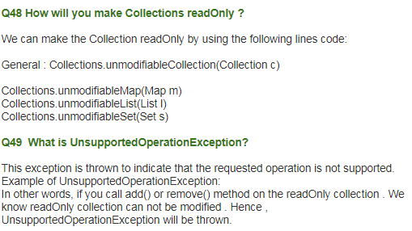

Top 10 HashSet Questions(Same website)

1. 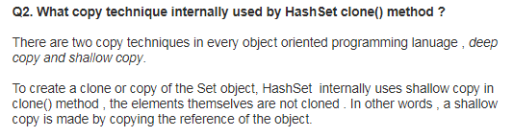
2. 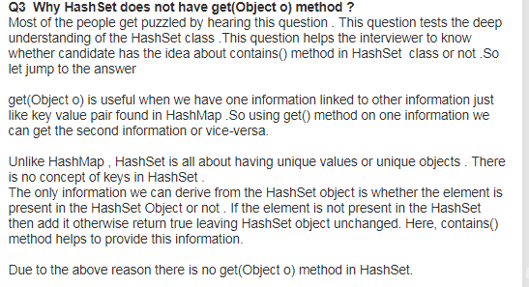
3. 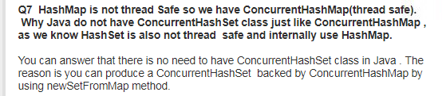

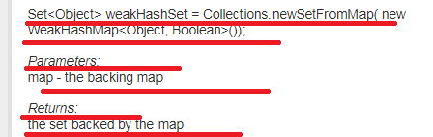

Core Java Threads Interview Questions(top 50 Questions),

1. 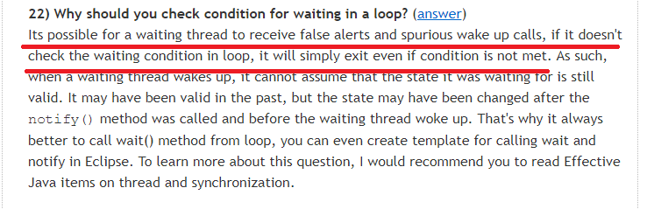
2. 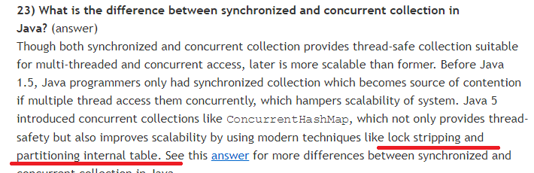
3. 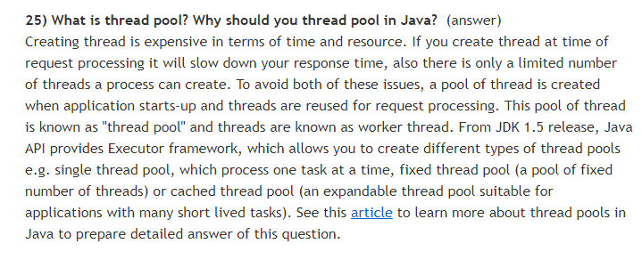
4. How do you check if a thread holds a lock or not🡺 by using Thread’s holdLock() method which returns true or false
5. Needed more information on Thread Dump in Java🡺 Then we will see the Question no 30
6. What is ReentrantLock in Java
7. 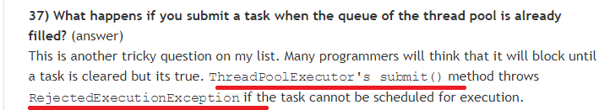
8. IllegalMonitorStateException🡺wait and notify should be called only inside Synchronized otherwise we will get this ex
9. IllegalThreadStateException🡺 setDaemon, calling Start() twice
10. **What is the difference between CyclicBarrier and CountDownLatch in Java**
11. **Write code to solve Producer Consumer problem in Java**
12. **What is the difference between Synchronized and ReentrantLock in java**
13. **What is Semaphore in Java**
14. **Needed Clear understanding on Thread pool**
15. **What is ReadWriteLock in java**
16. **What is the difference between the volatile and atomic variable in java**
17. **How to create thread-safe Singleton in java**

Exception Interview Questions

1. Note we cannot keep any statement after finally block also>🡺 check this
2. What is the difference ClassNotFoundException and NoClassDefFoundError

In java both ClassNotFoundException and NoClassDefFoundError occurs when a particular class is not found at run time. But they occur at different scenarios,

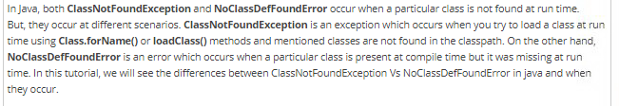

1. Throw is used to manually thrown an exception
2. How to create a customized exception in java🡺 NEEDED HANDS ON
3. **What are chained exceptions in java**

Exception Questions from Java Revisited

1. What is the best practices that you do while exception handling

* Non empty catch blocks
* Prefer Unchecked exception over checked exception until u have a very good reason
* Never let your database exception flowing till client error handle all db related exception in Dao layer itself
* Calling db related closing in finally block

1. 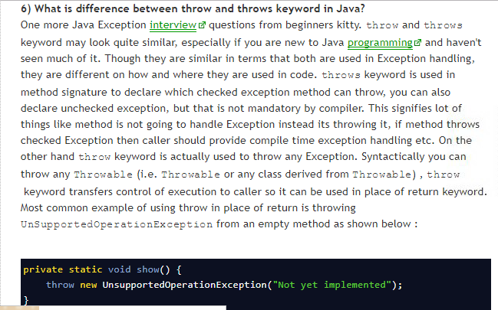
2. 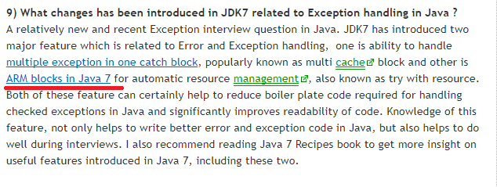
3. 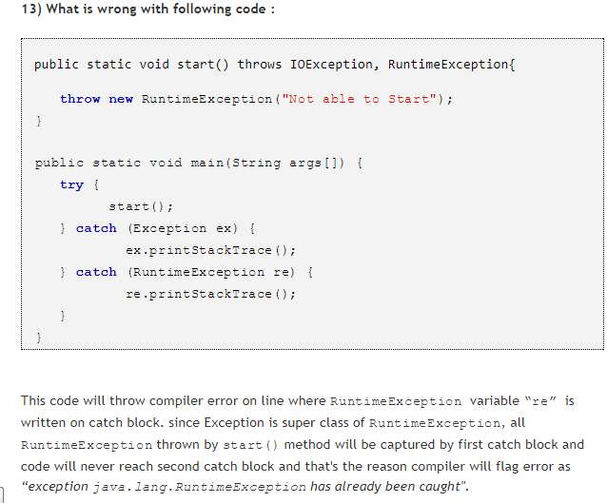
4. 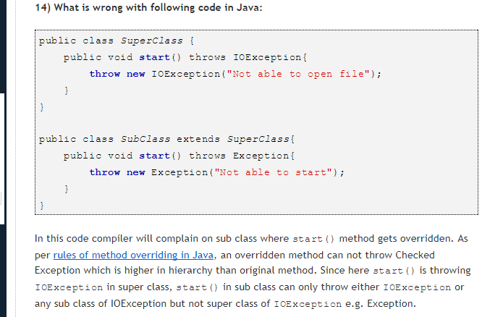
5. 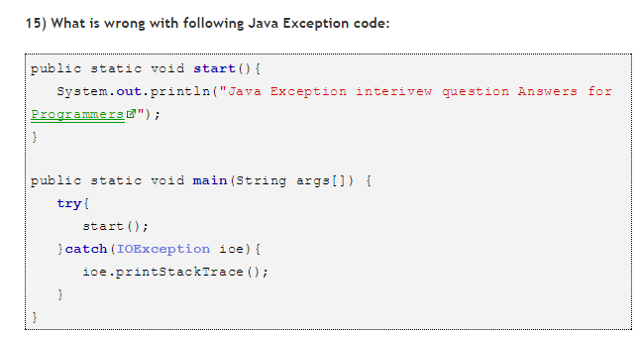

Explanation🡺

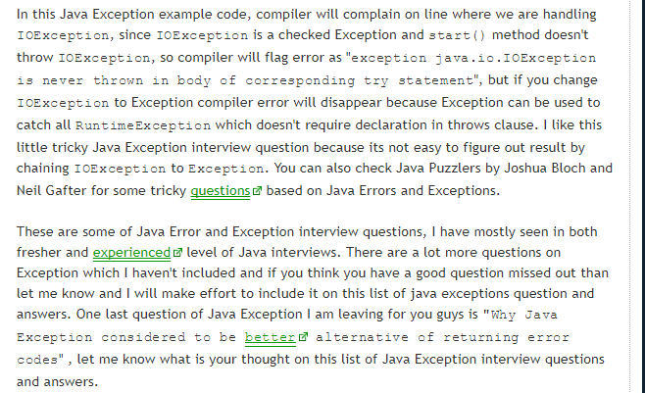

String interview Questions

From 35 Questions website

1. 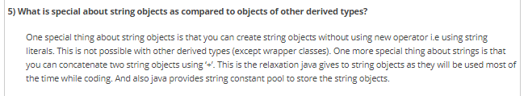
2. String, StringBuffer and StringBuilder all three are final
3. String class is also Thread safe
4. To convert given string to char array🡺 toCharArray()
5. 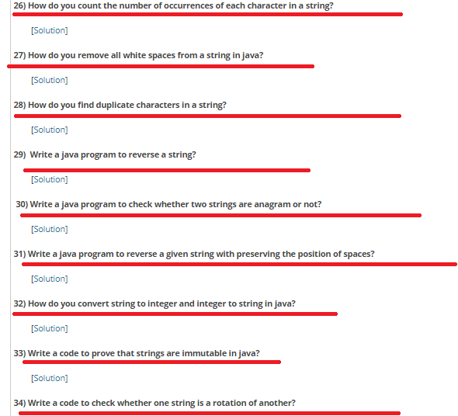
6. Write a program to reverse each word of a given string
7. Sorting an array of number in asc and desc order

Core Java String interview Questions (from Java revisited)

1. 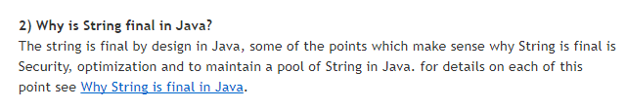
2. 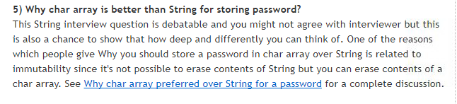
3. **compareTo and equals is used to compare 2 string in java**
4. String is immutable and Thread safe so can be shared across multiple threads without any external synchronization
5. 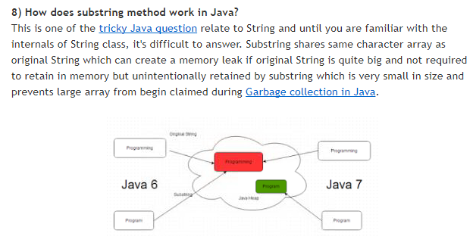
6. Look at the following programs output

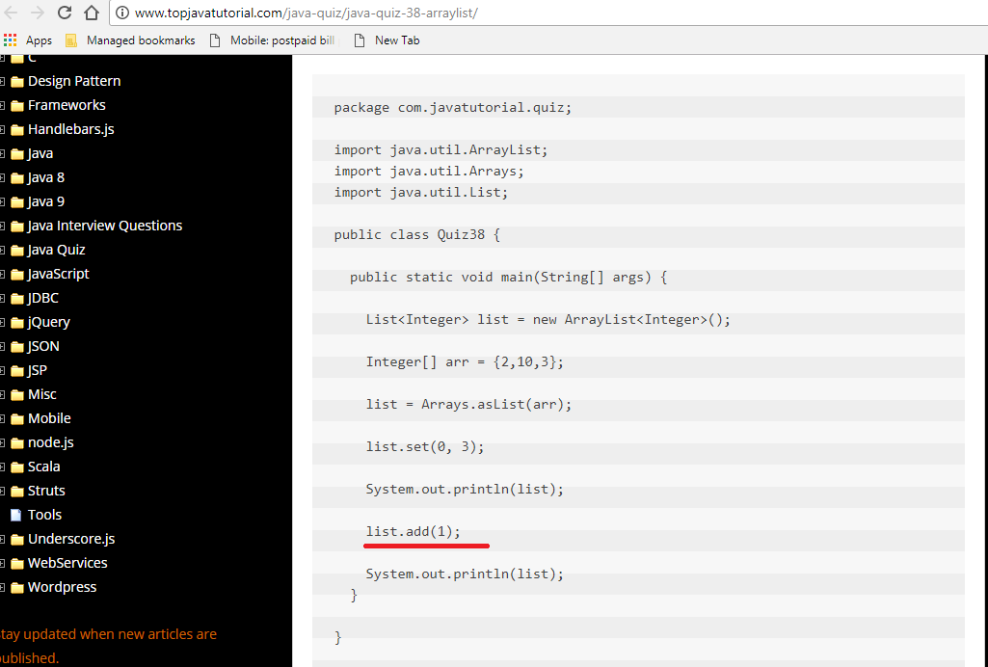

**Output🡺 WE GET UNSUPPORTED OPERATION EXCEPTION AT LINE list.add(1);**

1. Look at the following ternary operator



1. We have sort methods in
2. Collections.sort()
3. Arrays.sort()
4. Difference between Comparable and Comparator interfaces

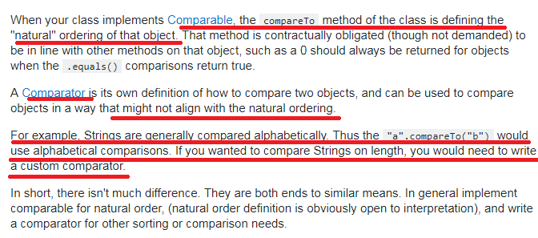

WebService

1. Annotations
2. @WebService(name=””

serviceName =””

portName=””

targetNameSpace=””

endpoint=””

)

1. @WebMethod(exclude=”true/false” operationName=””, action=””)
2. @SoapBinding(use=”literal/encoded”, style=”RPC/Document”)
3. @WebResult(partName =”here element name will come here”)
4. @WebParam(partName=”here element name will come here”)
5. @XmlRootElement
6. @XmlElement
7. **@XmlTy**pe(proporder={})
8. WSDL🡺Web Service Description language
9. SOAP🡺 Simple Object Access Protocol
10. UDDI🡺 Universal Description Discovery and Integration
11. WSD file sample🡺

<definition targetNameSpace=”” name=”NotifyBondLineService”>

<types>

<xsd:schema>

<xsd:schemalocation =””/>

</xsd:schema>

</types>

<message name =”getBondStatus” >

<part name=”parameter name” element=”element name as in XSD file”/>

</message>

<message name =” getBondStatusResponse” >

<part name=”parameter name” element=” element name as in XSD file”/>

</message>

<portType name =”NotifyBondline”>

<operation>

<input message=” getBondStatus”/>

<output message=” getBondStatusResponse”/>

<fault ></fault>

</operation>

</portType>

<binding name =”NotifyBondlineBinding”>

<soap:binding transport =”soap over http” style=”rpc/Document”>

<operation>

<soap:operation soapAction=”” />

<input>

<soap:body use =”literal”/>

</input>

<output>

<soap:body use =”literal”/>

</output>

</operation>

</binding>

<service name =”NotifyBondlineService”>

<port name =”NotifyBondlinePort” >

<soap:address>http://localhost/appnae/serviceName?wsdl</soap:address>

</port>

</service>

</Definition>

1. WS has provided as the following component,
2. WSDL
3. Skeleton
4. Stub
5. SOAP
6. HTTP
7. UDDI🡺 Universal Description Discovery and Integration
8. WS is for applications interaction
9. A Simple flow Explanation🡺 see the notes🡺 provider has Skeleton and Consumer has Stub where Stub and Skeleton(IS A SERVLET CLASS) has Same Method Declaration as SEI but Logic is to covert Java req and Res to SOAP req and res
10. We have 4 implementers of WS namely,(again this 4 are specifications only we need implementation)
11. JAX-RPC
12. JAX-M🡺 is for async
13. JAX-WS
14. JAX-RS
15. Eclipse will support only 3 implementations it seems for remaining we need some plugins,
16. Axis1
17. Axis2
18. Apache CXF
19. AXIS-1 example🡺 is the implementer of JAX_RPC
20. Service endpoint Url syntax🡺http://localhost:8080/webappName/skeletonUrl/unique Name of the Service
21. AXIS-1 uses server-config.wsdd(will be present in web-inf folder and this file also contains class ,method and parameters details of a service) file in order to map unique name to the Service

Syntax🡺

<ns:service name=”Unique name of Service”-------- >

<ns1:parameter name=”**allowedMethods**” value=”add sub multiply”/>

1. WSDL GENERATION TOOL is 🡺org.apache.axis.wsdl.java2wsdl 🡺 this is a class that is acting as a WSDL generator
2. java2wsdl WSDL generator needs following information to generate WSDL
3. Service Class
4. endpoint url
5. wsdl file name
6. targetnamespace
7. web.xml file will have skeleton information
8. Steps to create WS provider and Consumer in STS see the notes
9. Final url to be hit in the Browser🡺 <http://localhost:8080/webappName/skeletonUrl/unique?wsdl>
10. In WS we have 2 types of Clients(a client app can be Standalone or web app)
11. Proxy based Client🡺 see the notes
12. DII client🡺 Dynamic Invocation Interface🡺 here we will not generate stub , ws implementors provide few set of classes that acts as a stub to call ws methods
13. Ms to invoke Service class methods we need its reference type, for getting the ref type we will use Service class of Java and URL class of Java🡺URL will have a wsdl location and Service class will have some sort of reference to SEI.
14. Axis2 Example🡺
15. Here Skeleton used is 🡺org.apache.**axis2**.transport.http.AxisServlet
16. Stub and WSDL generation see the notes

SOAP

1. SOAP🡺 Simple Object access protocol
2. IS a Messaging protocol
3. IN WS errors/exceptions are called as Faults
4. Soap contains 3 parts
5. Soap-envelope
6. Soap-header
7. Soap-Body
8. If req is failed then Soap Message will contain 4th Section called🡺 Soap-fault
9. Syntax🡺

<?xml version=”1.0”?>

<soap: Envelope xmlns: soap=”http:------------“

Soap:encodingstyle=”http:-------“>

<soap:header>

------

</soap:header>

<soap:body>

-------

<soap:fault>

------

</soap:fault>

</soap:body>

</soap: Envelope>

1. Here Servlet class used is (I don’t know the Exactly which implementation is this)

<servlet-class>Com.sun.xml.ws.transport.http.servlet.WSServlet</servlet-class>

Note🡺 **for this servlet some Listener class is also used**

WebService interview Questions

1. 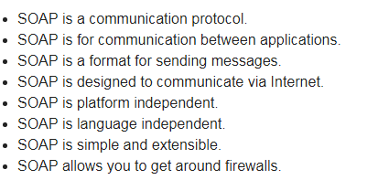
2. 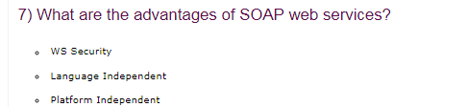
3. 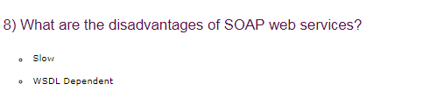
4. 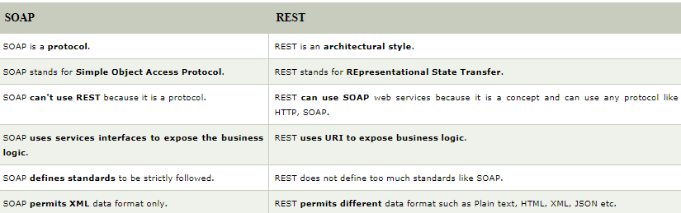

Questions from Journal Dev

1. 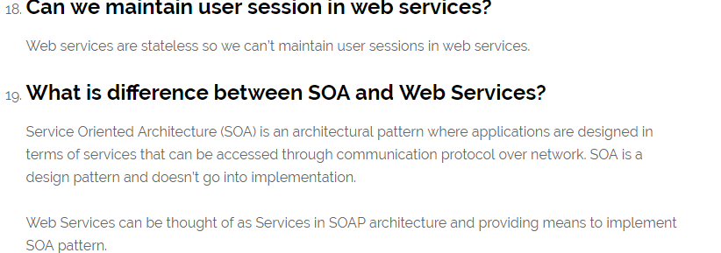
2. What is the use of Accept and Content-Type Headers in HTTP Request?

Content-Type header🡺 is used to tell server what is the format of data being sent in the request. If Content-Type header is “application/xml” then server will try to parse it as XML data. This header is useful in HTTP Post and Put requests..

Accept🡺 later

1. JAX-WS stands for Java API for XML Web Services. JAX-WS is XML based Java API to build web services server and client application.
2. 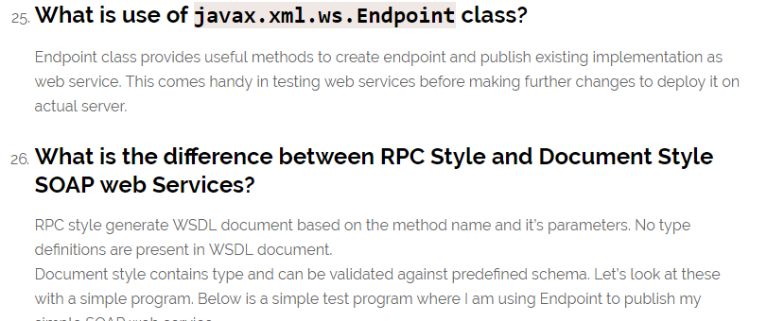
3. **WSDL document can be accessed by appending ?wsdl to the SOAP endpoint URL. In above example, we can access it at http://localhost:8888/testWS?wsdl location.**

### What is wsimport utility?

We can use wsimport utility to generate the client stubs. This utility comes with standard installation of JDK. Below image shows an example execution of this utility for one of JAX-WS project.

1. 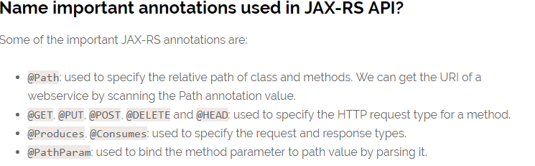

NOTE🡺 I HAVE NOT COVERED MOST OF THE REST SERVIC EINTERVIEW QUESTION

Rest Service

1. Rest🡺Representational state transfer
2. REST is an architecture
3. REST service don’t have such WSDL specification file thus URL or URI itself is a specification for rest services to access the web service
4. In case of rest client will directly use the uri to get response
5. SOAP is a Protocol and REST is a architecture
6. Soap permits XML data format only but REST allows different formats like HTML, XML, JSON and etc...
7. SOAP supports different types of protocols like http protocol, RMI protocols. But REST supports only Http and https
8. REST do not need client generation, wsdl generation and etc..
9. Jersey is the implementation of JAX-RS
10. Apache CXF also provides implementation for JAX-RS
11. HTTP Methods,
12. Get🡺 to get information from Server
13. Post🡺 to send or save information in the server
14. Put🡺 is use to update data of that URL
15. Delete🡺 to delete data of that URL
16. Metadata🡺 along with req and res we also have header information which is Meta data
17. HTTP Status Code,
18. 2xx🡺 success
19. 1xx🡺informational
20. 3xx🡺redirection
21. 4xx🡺Client error
22. 5xx🡺Server error
23. We can pass the input parameters to operation In 2 ways for a rest service
24. Request params
25. Path parameter
26. Syntax for Path parameter🡺

Baseurl/100🡺 where 100 is employee id this is sent as method input

1. Syntax for Request parameter or Query Parameter,

baseURL**?id**=1

Note🡺 Query parameter is not like a path parameter its additional parameter that gets added to http header

1. As discussed early along with req and res we have header information🡺 note we have req header and response header
2. List of annotations used
3. @Path🡺 both at class level and method level
4. @Produces🡺is used to, what we want to return from WS 🡺 ms is method level @
5. @Consumes🡺 is used to, what we want to send to WS🡺 ms is method level @
6. @PathParam
7. @Get
8. @Post
9. @Put
10. @Delete
11. JSON will store the value in the form of key and value pair
12. JSONLint is used to validate JSON.
13. @Produces(MediaType.APPLICATION_JSON)
14. Example
15. web.xml🡺 root tag for web.xml is <web-app>

<servlet>

------

<servlet-class>org.glassfish.jersey.servlet.ServletContainer</ servlet-class>

<initiparam>

<param-name>jersey.config.server.provider.packages</param-name>

<param-value>com.capgemini.services</param-value>

</initiparam>

<load-on-startup>1</ load-on-startup>

</servlet>

<init-param>🡺 in our app we might have 10 packages among this 10 packages only one package will have all service classes thus we need to tell JAX_RS from where or which package it should start searching for WS classes

1. Java file

@Path(“/Capgemini”)

Public class NotifyNondlineRestService

{

@GET

@Path(“{a}/{b}”)

Public int add (@PathParam(“a”) int a, @PathParam(“b”) int b)

{

Return a+b;

}

}

1. Output🡺

http:..loclahost:8080/applicationContext/url in web.xml file/url as in @path annotation**/10/20**

NEEDED TO KNOW WAX-RS IMPLEMENTATION THAT IS USED IN THE APPLICATION

WHAT IS THE JPA VERSION USED IN THE PROJECT

Angular Material Design Elements

1. <mat-form-field>
2. <mat-autocomplete #variableName=”matautocomplete”>
3. <input [matautocomplete]=” variableName”>
4. <mat-option>
5. <mat-checkbox>🡺 labelPosition
6. <mat-radio> and <mat-radio-group>
7. <mat-datepicker #variable>🡺 startat and startView=”year/month”
8. <input [matDatepicket]=” variable”>
9. <textarea matTextArea>
10. <mat-select>🡺 placeholder=”auto/always/never” and hideRequiredMarker=true/false

* <mat-option>None</mat-option>

1. <mat-placeholder>
2. <mat-hint>🡺 align =”start/end”

Or

hintLabel=”value”🡺 by default it starts at start position

1. <mat-error>
2. Matsuffix and matprefix🡺 are properties
3. <mat-slider horizontal/vertical>🡺 similar to <input type="range">🡺 properties🡺 step, min, max
4. <mat-slide-toggle>
5. 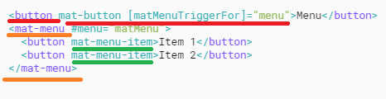
6. <mat-menu yPosition =”above/below” xPosition =”after/before”
7. <mat-icon>
8. <mat-sidenav>
9. <mat-toolbar>Heading</mat-toolbar>
10. <mat-list>

<mat-list-item>”Value”</mat-list-item>

</mat-list-item>

1. 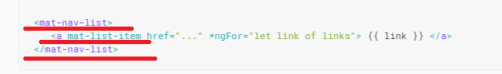
2. 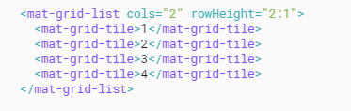
3. <mat-card>Card name</mat-card>
4. Stepper
   1. <mat-horizontal-stepper>

<mat-step>

<form >

**<ng-template matsteplabel>”here enter the label”</ng-template>**

<mat-form-field>

<input>

</mat-form-field>

<button mat-button/mat-raised-button>

</form>

</mat-step>

1. <button mat-button matStepperPrevious>Back</button>
2. <button mat-button matStepperNext>Next</button>
3. <mat-tab-group>

<mat-tab></mat-tab>

<mat-tab></mat-tab>

</mat-tab-group>

1. 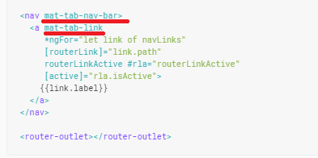
2. <mat-expansion-panel>🡺 has one sub element <mat-expansion-panel-header>🡺

“mat-expansion-panel-header” this has two sub-element🡺<mat-panel-title> and <mat-panel-description>

1. There is no body element and all for this expansion panel it has a <mat-form-field> in example
2. <mat-accordion multi=”true/false”>
3. <mat-button-toggle>
4. <mat-chip-list **aria-orientation=”vertical”**>

<mat-chip>

<mat-chip>

<mat-chip-list>

1. <mat-spinner></mat-spinner>
2. <mat-progress-bar></mat-progress-bar>🡺 mode=”determinate/indeterminate/buffer/query”
3. Popup’s and modal🡺**MatDialog has the methods/functions like open(), close() and afterClosed() methods**

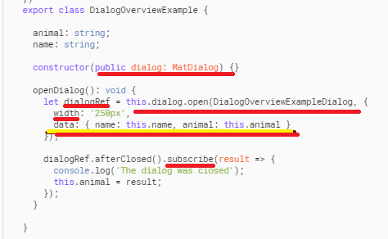

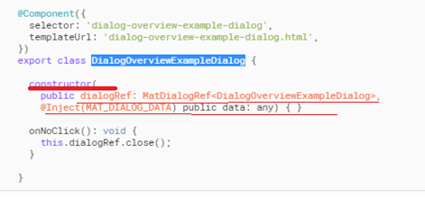

1. <span matTooltip=”this is hidden initially and displayed on mouse over”>I have a tooltip</span>
2. **matTooltipPosition** 🡺above, below, left, right, after, before
3. MatSnackBar🡺 has a methods like open()

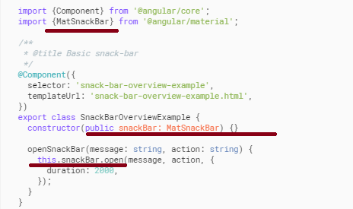

Angular 2

1. Npm🡺 Nope package manager
2. npm init –y🡺 this is used to generate package.json
3. npm install packagename1, packageNmae2 --save –dev
4. npm shrinkwrap🡺
5. package-son🡺 has scripts, dependencies and devDependencies(this is project or requirement specific jars/modules)

* scripts🡺 has post install : ”Typings install”🡺 this command is used to tell npm to download typing installs once its done with downloading package.json files dependencies

1. tsconfig.json🡺 has a configuration information that is needed by the typescript compiler to compile(actually this process is called as transpilation) TS code to JS

Few of the information’s that this file contains is🡺

* Default :es5🡺 here we tell tsc to compile ts code to ecma5 standards
* Emit decorator metadata : true🡺 for true value metadata will be emitted it seems
* Experimental decorator metadata : true

1. Typings.json🡺 has a typescript understandable jars(ms package.json🡺 has JS understandable libraries
2. System.config.js and webpask.js 🡺 this are bundling tools🡺 used to bundle all our ts code into single js file called main.js and along with our main.js we also have vendor.js(third party code used in our app) and polfills.js(this is used for browser compatibility)
3. Syntax for system.config.js and Webpack.js 🡺 we will take screen shot later after connecting to net
4. interpolation🡺{{propertyName}}🡺 is one way data binding (Ms🡺it’s from Component to View)
5. **Needed a clear understanding on a single page application**
6. **Needed more information on ngModelChange🡺 with an example**
7. ElementRef allows us to access the DOM element.
8. data binding or property binding🡺 []🡺

example 🡺 <p **[hidden]=”Comes_fromComponent**”> or <img [src]= “Comes_fromComponent”>

1. event binding <p **(click)** =” Comes_fromComponent”>
2. two way data binding 🡺[()]🡺 for this we use ngModel(this is from FormsModule)
3. /. 🡺 indicates current directory
4. /.. 🡺 indicates immediate parent directory
5. ``🡺 back ticks is used to insert multi line html code
6. Component🡺 is for view development🡺 is class + metadata
7. Directive🡺 is used to achieve dynamic view
8. 3 Types of Directives,
9. Component directive

@Componnet({

Selector:’’,

Template/templateUrl:``

Style/styleurl:[

H2

{

bgcolor:’red’

}

]

})

1. Structural directive🡺 starts with *
2. *ngIf
3. *ngFor
4. [ngstwith]=” **Comes_fromComponent” 🡺**ngSwitchWhen=”Value1”, ngSwitchDefault=””
5. Attribute directive
6. [ngClass] 🡺

<p [ngClass] =”

{

classOne: ‘**Comes_fromComponent’**

classTwo: ‘ **Comes_fromComponent’**

}

>Hello Lets see which and all class style gets applied </p>

Style:[

.classOne{

Color:red,

}

.classTwo{

Font-size:12px

}

]

1. [ngStyle]🡺 later
2. Class binding🡺 Example🡺

<p [class.classname] =” **Comes_fromComponent**”>If Condition is true means Style of classname gets applied</p>

Style: [

.classname

{

Color: green;

}

]

1. Style Binding🡺

<div [style.color] =” **Comes_fromComponent** ? ‘red’: ‘green’”>for me style gets applied if based on ternary operator condition.

1. Example for event binding🡺

<input type=”text” #variable>

<button (click)=”goToNext(variable.value)” >

1. @NgModule({

Imports:[ list of all the modules that is needed by my app],

Exports:[],

Declaration:[ list of all the Components, pipes that is needed by my app ]

Providers:[]

})

1. Angular provides 3 types of forms
2. Template Driven forms
3. Model Driven forms
4. Model Driven forms with FormBuilder
5. Template Driven form🡺
6. We use list of boot strap classes🡺 containers, form-group, form-control
7. <form #userForm= ”**ngForm**” (ngSubmit) =”onSubmit(userForm.values)>

<div>

<label ----- ></label>

<input ----------- [(**ngModel**)] =”**propertyNameFromComponent**”>

</div>

</form>

1. Few of the TDF ng directives validators🡺

* Ng-touched
* Ng-untouched
* Ng-pristine and ng-dirty
* Ng-valid and ng-invalid
* Minlength =””
* Maxlength =””
* Pattern=””
* Required

1. Model Driven forms🡺this uses ReactiveFormsModule, FormGroup class, FormControl class
2. Example🡺

userForm = new FormGroup(

{

Name : new FormControl(),

Age : new FormControl(),

Address : new FormGroup({

Street1: new FormControl(),

City : new FormControl()

})

}

)

Equivalent html code

<form [**formGroup**] =” userForm”>

<div >

<label>Name</label>

<input ------- **formControlName=”name[SameAsinComponent]”** />

</div>

<div **formGroupName**=””**address[SameAsinComponent]**>

<label>City</label>

<input ------- **formControlName=”city[SameAsinComponent]”** />

</div>

</form>

1. Model Driven form With FormBuilder🡺

**constructor**(private fB : FormBuilder ){}

1. ngOnInit(){

userForm : FormGroup = fb.group({

name:[‘defaultValue,[Validators array]],

email:[‘defaultValue,[Validators array]],

address:fb.group({

street:[],

city:[],

state:[]

})

})

}

1. Steps involved in Service creating using Dependency Injections
2. Create Service
3. Register the service🡺 using providers attribute o @Component or @NgModule
4. Declare a service🡺 In a constructor
5. An example on observable🡺

return this.http.get(url).map(res: Response=> res.json()).subscribe(response=>this.output =response);

1. @Injectable🡺 this emits some metadata at Compilation time which we can see in JS files
2. RoutingModule🡺 <router-outlet> routerlink, and routerlinkactive🡺 is some boot strap class

<router-outlet></router-outlet>🡺 this is where my component gets rendered

1. To use routing we need <base href =”/”> tag in the <head> element of index.html
2. RouterModule.forRoot({

path:’’,

component:ComponentFileNamess

})

1. Syntax for Parameterized routing
2. {

path: “employeeDetails**|:id**,

component: ComponentFileName

}

|:id🡺 is a place holder and this should math with a params observable input name

1. To use snapshot we need to use ActivatedRoute
2. Snapshot is used to take screen shot of the current url
3. This.router.navigate**([‘/emplojeeDetails’, IDValueOfStringType]) 🡺**

syntax is([url, valueOfStringType])

1. Now we need to capture the value that is taken by snapshot for that we use params observables
2. Let id = parseInt(this.route.snapshot.params[‘id_same_as_used_in_Path attribute of forRoot method])’
3. There is some disadvantage with snapshot that is why we use params 🡺 reason given was because of ngOnInit() is called only once so snapshot is called only once so its not able to detect any changes in the url but params though its present in ngOnInit() though ngOnInit () is called only once in the ,Params Observable is capable of detecting any changes in the URL and captures that changes though ngOnInit() Is not called again
4. Params Observables🡺

This.route.params.subscribe(

params Params =>

{

let id = parseInt*(*params[id_same_as_used_in_Path attribute of forRoot method])

this.employeeId =id;

}

)

1. Optional Route Parameters

this.route.navigate([‘/employeeDetails’,

**{id:selectedId}**

])

🡺{id:selectedId}🡺this is like {key:value} pair

1. Inputs and Outputs
2. Pipes🡺pipe symbol is |
   1. <h2>{{name|slice:’2’}}</h2>
   2. <h2>{{name|slice:’2:’4’}}</h2>
   3. <h2>{{name|upperCase}}</h2>
   4. <h2>{{name|lowerCase}}</h2>
   5. <h2>{{value|number:’2:2-3’}}</h2>
   6. <h2>{{value|currency:’USD’}}</h2>
   7. <h2>{{value|currency:’Euro’ }}</h2>
   8. <h2>{{dateValue|date:’fullDate’}}</h2>
   9. <h2>{{dateValue|date:’shortDate’}}</h2>
   10. <h2>{{dateValue|date:’mediumTime’}}</h2>
3. Core-js🡺 ECMA script 6 has few global objects like “Promise” which cannot be understand by Browser so, Package.json has this core.js to help browser in converting this ecma6 code to ecma 5 code

Similarly Typings.JSon also have core-js it’s because in TSconfig.json we have defaulted TypeScript Complier to ecma5 so TSC cannot understand ECMA6 code so for this in order to help TSC typings.json has core.js module/jar/library

1. reflect-metadata🡺 this allows angular to use the meta data we pass to the component decorator
2. rxjs🡺 is a library used to work with Observables.
3. Zone.js🡺Is used for Async function
4. **Let’s see the content of system.config.js and Webpack.js content later**
5. **Life cycle hooks of Component and Pipes**

SQL

NEEDED MORE INFORMATION ON THIS BELOW QUERY

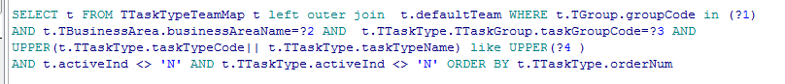

WHERE T.DEFAULTtEAM= t.TGroup

**Self-join notes (must see this once)**

**From the Website 🡺http://www.programmerinterview.com/index.php/database-sql/what-is-a-self-join/**

**What is a self join? Explain it with an example and tutorial.**

Let’s illustrate the need for a self join with an example. Suppose we have the following table – that is called employee. The employee table has 2 columns – one for the employee name (called employee_name), and one for the employee location (called employee_location):

|  |
| --- |
| employee |
| |  |  | | --- | --- | | **employee_name** | **employee_location** | | Joe | New York | | Sunil | India | | Alex | Russia | | Albert | Canada | | Jack | New York | |

Now, suppose we want to find out which employees are from the same location as the employee named Joe. In this example, that location would be New York. Let’s assume – for the sake of our example – that we can ***not*** just directly search the table for people who live in New York with a simple query like this (maybe because we don’t want to hardcode the city name) in the SQL query:

SELECT employee_name

FROM employee

WHERE employee_location = "New York"

So, instead of a query like that what we could do is write a nested SQL query (basically a query within another query – which is more commonly called a subquery) like this:

|  |
| --- |
| SELECT employee_name  FROM employee  WHERE employee_location in  ( SELECT employee_location  FROM employee  WHERE employee_name = "Joe") |

**A subquery is inefficient**

**Using a subquery for such a simple question is inefficient.** Is there a more efficient and elegant solution to this problem?

It turns out that there is a more efficient solution – we can use something called a ***self join***. A self join is basically when a table is joined to itself. The way you should visualize a self join for a given table is by imagining that a join is performed between ***two identical copies of that table***. And that is exactly why it is called a ***self*** join – because of the fact that it’s just the same table being joined to another ***copy*** of itself rather than being joined with a different table.

**How does a self join work**

Before we come up with a solution for this problem using a self join, we should go over some concepts so that you can fully understand how a self join works. This will also make the SQL in our self join tutorial a lot easier to understand, which you will see further below.

**A self join must have aliases**

|  |
| --- |
|  |

In a self join we are joining the same table to itself by essentially creating two copies of that table. But, how do we distinguish between the two different copies of the table – because there is only one table name after all? Well, when we do a self join, the table names absolutely must use aliases otherwise the column names would be ambiguous. In other words, we would not know which of the two copies of the table’s columns is being referenced without using an alias for each copy of the table. If you don’t already know what an alias is, it’s simply another name given to a table – think of an alias as a nickname – and that nickname is then used in the SQL query to reference the table. Because we need two copies of the employee table, we will just use the aliases e1 and e2 for the employee table when we do a self join.

**Self join predicate**

As with any join there must be a condition upon which a self join is performed – we can not just arbitrarily say “do a self join”, without specifying some condition. That condition will be our join predicate. If you need a refresher on join predicates (or just joins in general) then check this link out: [Inner vs. Outer joins](http://www.programmerinterview.com/sql/inner-vs-outer-joins.php).

Now, let’s come up with a solution to the original problem using a self join instead of a subquery. This will help illustrate how exactly a self join works. The key question that we must ask ourselves is what should our join predicate be in this example? Well, we want to find all the employees who have the same location as Joe.

Because we want to match between our two tables (both of which are the same table – employee – aliased as e1 and e2) on location our join predicate should clearly be “WHERE e1.employee_location = e2.employee_location”. But is that enough to give us what we want? No, it’s not, because we also want to filter the rows returned since we only want people who are from the same location as Joe.

So, how can we filter the rows returned so that only people from Joe’s location are returned? Well, what we can do is simply add a condition on one of the tables (e2 in our example) so that it only returns the row where the name is Joe. Then, the other table (e1) will match up all the names that have the same location in e2, because of our join predicate – which is “WHERE e1.employee_location = e2.employee_location”. We will then just select the names from e1, and not e2 because e2 will only have Joe’s name. If that’s confusing then keep reading further to understand more about how the query will work.

So, the self join query that we come up with looks like this:

**Self Join SQL Example**

|  |
| --- |
| SELECT e1.employee_name  FROM employee e1, employee e2  WHERE e1.employee_location = e2.employee_location  AND e2.employee_name="Joe"; |

This query will return the names Joe and Jack – since Jack is the only other person who lives in New York like Joe.

Generally, queries that refer to the same table can be greatly simplified by re-writing the queries as self joins. And, there is definitely a performance benefit for this as well.

**What does a self join look like?**

It will help tremendously to actually visualize the actual results of a self join internally. Remember that a self join is just like any other join, where the two tables are merged into one temporary table. First off, you should visualize that we have two separate copies of the employee table, which are given aliases of e1 and e2. These copies would simply look like this – note that we shortened the column names from employee_name and employee_location to just Name and Location for convenience:

|  |  |
| --- | --- |
| e1 | e2 |
| |  |  | | --- | --- | | Name | Location | | Joe | New York | | Sunil | India | | Alex | Russia | | Albert | Canada | | Jack | New York | | |  |  | | --- | --- | | Name | Location | | Joe | New York | | Sunil | India | | Alex | Russia | | Albert | Canada | | Jack | New York | |

And the final results of running the self join query above – the actual joined table – would look like this:

|  |  |  |  |
| --- | --- | --- | --- |
| e1.employee_name | e1.employee_location | e2.employee_name | e2.employee_location |
| Joe | New York | Joe | New York |
| Jack | New York | Joe | New York |

**Self joins versus inner joins**

|  |
| --- |
|  |

Are self joins and inner joins the same? You might be wondering if all self joins are also inner joins. After all, in our example above our self join uses an inner join because only the rows that match based on the join predicate are returned – non-matching rows are not returned. Well, it turns out that a self join and inner join are completely different concepts. A self join could just as well be an outer join or an inner join – it just depends on how the query is written. We could easily change the query we used above to do a LEFT OUTER JOIN – while the query still remains a self join – but that wouldn’t give us the results we want in our example. So, we use an implied inner join instead because that gives us the correct results. Remember that a query is a self join as long as the two tables being joined are exactly the same table, but whether it’s an inner join or outer join depends on what is specified in the SQL. And, inner/outer joins are separate concepts entirely from a self join.

NOTE 🡺 IN THIS NOTES ONLY I HAD OBSERVED THE INNER JOIN WAS APPLIED ON SAME TABLE

**Self joins manager employee example**

The most commonly used example for self joins is the classic employee manager table. The table is called Employee, but holds all employees – including their managers. Every employee has an ID, and there is also a column for the manager ID. So, for example, let’s say we have a table that looks like this – and we call it Employee:

|  |  |  |
| --- | --- | --- |
| EmployeeID | Name | ManagerID |
| 1 | Sam | 10 |
| 2 | Harry | 4 |
| 4 | Manager | NULL |
| 10 | AnotherManager | NULL |

Notice that in the table above there are two managers, conveniently named “Manager” and “AnotherManager”. And, those managers don’t have managers of their own – as noted by the NULL value in their Manager column.

Now, given the table above, how can we return results that will show each employee’s name, and his/her manager’s name in nicely arranged results – with the employee in one column and his/her manager’s name in the other column. Well, it turns out we can use a self join to do this. Try to come up with the SQL on your own before reading our answer.

**Self join manager employee answer**

In order to come up with a correct answer for this problem, our goal should be to perform a self join that will have both the employee information and manager information in one row. First off, since we are doing a self join, it helps to visualize the one table as two tables – let’s give them aliases of e1 and e2. Now, with that in mind, we want the employee’s information on one side of the joined table and the manager’s information on the other side of the joined table. So, let’s just say that we want e1 to hold the employee information and e2 to hold the corresponding manager’s information. What should our join predicate be in that case?

Well, the join predicate should look like “ON e1.ManagerID = e2.EmployeeID” – this basically says that we should join the two tables (a self join) based on the condition that the manager ID in e1 is equal to the employee ID in e2. In other words, an employee’s manager in e1 should have the manager’s information in e2. An illustration will help clarify this. Suppose we use that predicate and just select everything after we join the tables. So, our SQL would look like this:

SELECT *

FROM Employee e1

INNER JOIN Employee e2

ON e1.ManagerID = e2.EmployeeID

The results of running the query above would look like this:

|  |  |  |  |  |  |
| --- | --- | --- | --- | --- | --- |
| e1.EmployeeID | e1.Name | e1.ManagerID | e2.EmployeeID | e2.Name | e2.ManagerID |
| 1 | Sam | 10 | 10 | AnotherManager | NULL |
| 2 | Harry | 4 | 4 | Manager | NULL |

Note that there are only 2 rows returned – this is because an inner join is performed, which means that only when there is a match between employee ID’s and manager ID’s will there be a result returned. And since there are 2 people without managers (who have a manager ID of NULL), they will not be returned as part of table e1, because no employees have a matching ID of NULL.

Now, remember that we only want to return the names of the employee and corresponding manager as a pair. So, we can fine-tune the SQL as follows:

SELECT e1.Name, e2.Name

FROM Employee e1

INNER JOIN Employee e2

ON e1.ManagerID = e2.EmployeeID

Running the SQL above would return:

Sam AnotherManager

Harry Manager

And that is the answer to the employee manager problem using a self join! Feel free to post any comments.

[**Hiring? Job Hunting? Post a JOB or your RESUME on our JOB BOARD >>**](http://www.programmerinterview.com/jobs)

7/11/2017

# [**Difference between PARTITION BY and GROUP BY**](https://stackoverflow.com/questions/2404565/sql-server-difference-between-partition-by-and-group-by)🡺 STACK OVER FLOW

1. We can take a simple example
2. we have a table named TableA with the following values .

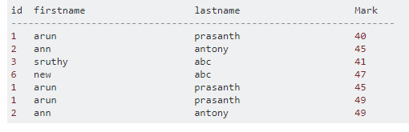

1. 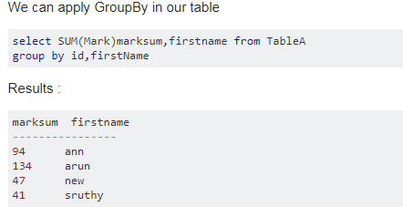

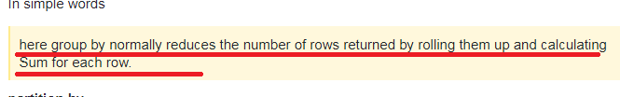

Now lets look at partition by

1. 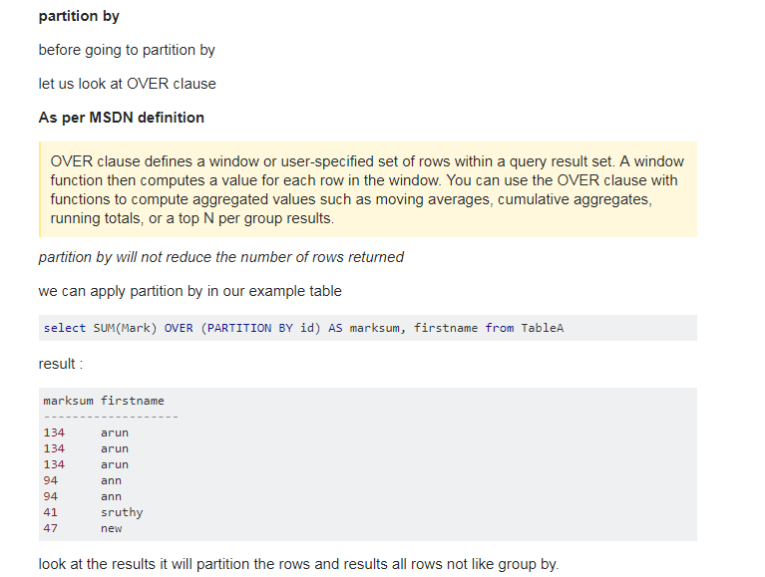

**SQL NOTES**

28/2/2017

This Notes are prepared from various web site and one among them for View is 🡺

<http://sql-plsql.blogspot.in/2009/03/insert-update-delete-views.html>

1. Triggers, which are procedures written in \, Java, or C that run (fire) implicitly whenever a table or view is modified or when some user actions or database system actions occur.
2. You can write triggers that fire whenever one of the following operations occurs: DML statements on a particular schema object, DDL statements issued within a schema or database, user logon or logoff events, server errors, database startup, or instance shutdown.
3. Oracle lets you define procedures called **triggers** that run implicitly when an INSERT, UPDATE, or DELETE statement is issued against the associated table or, in some cases, against a view, or when database system actions occur. These procedures can be written in PL/SQL **or Java and stored** in the database, or they can be written as C callouts.
4. Graphical representation,

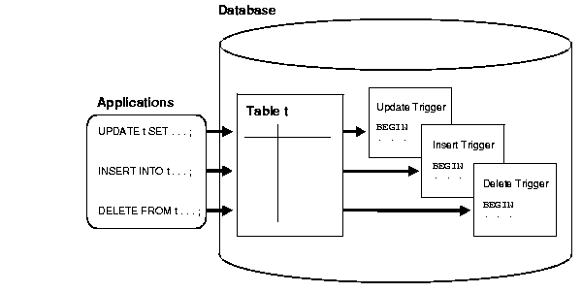

1. Uses of the Triggers,
2. A trigger can restrict DML operations against a table to those issued during regular business hours.
3. Automatically generate derived column values
4. Prevent invalid transactions
5. Modify table data when DML statements are issued against views 🡺as we know that views are mirror image of the tables used for security purpose.

***Cascading Triggers***

Let’s see the graphical image to understand the cascading triggers,

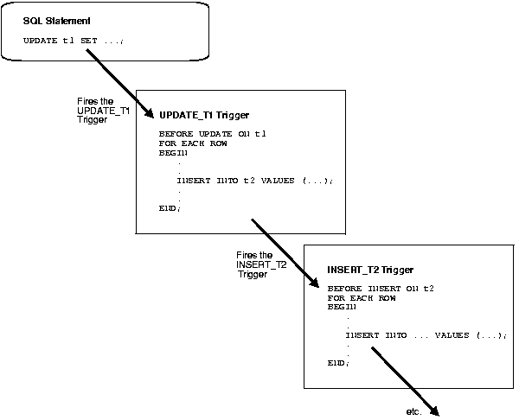

## Parts of a Trigger

1. A trigger has three basic parts:

* A triggering event or statement
* A trigger restriction
* A trigger action

### Trigger Restriction

1. A trigger restriction specifies a Boolean expression that must be true for the trigger to fire. The trigger action is not run if the trigger restriction evaluates to false or **unknown**.

### Trigger Action

A trigger action is the procedure (PL/SQL block, Java program, or C callout) that contains the SQL statements and code to be run when the following events occur:

* A triggering statement is issued.
* The trigger restriction evaluates to true.

## Types of Triggers

the different types of triggers:

* [Row Triggers and Statement Triggers](https://docs.oracle.com/cd/B10500_01/server.920/a96524/c18trigs.htm#2174)

* [BEFORE and AFTER Triggers](https://docs.oracle.com/cd/B10500_01/server.920/a96524/c18trigs.htm" \l "789)

* [INSTEAD OF Triggers](https://docs.oracle.com/cd/B10500_01/server.920/a96524/c18trigs.htm" \l "10901)

* [Triggers on System Events and User Events](https://docs.oracle.com/cd/B10500_01/server.920/a96524/c18trigs.htm" \l "10004)

### Row Triggers and Statement Triggers

Row Trigger 🡺 Once for every row affected by the triggering statement, such as a trigger fired by an UPDATE statement that updates many rows 🡺 For example, if an UPDATE statement updates multiple rows of a table, a row trigger is fired once for each row affected by the UPDATE statement. If a triggering statement affects no rows, a row trigger is not run.

Statement Triggers🡺Once for the triggering statement, no matter how many rows it affects

### BEFORE and AFTER Triggers

When defining a trigger, you can specify the **trigger timing**--whether the trigger action is to be run before or after the triggering statement. BEFORE and AFTER apply to both statement and row triggers.

* BEFORE triggers run the trigger action before the triggering statement is run 🡺 uses is 🡺To derive specific column values before completing a triggering INSERT or UPDATE statement.
* AFTER triggers run the trigger action after the triggering statement is run.

#### Trigger Type Combinations

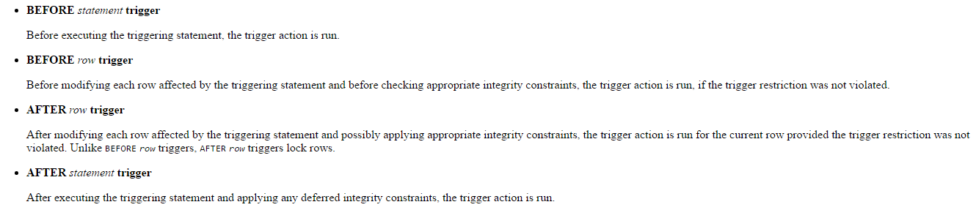

### INSTEAD OF Triggers

(1) INSTEAD OF triggers provide a transparent way of modifying views that cannot be modified directly through DML statements (INSERT, UPDATE, and DELETE). These triggers are called INSTEAD OF triggers because**,** unlike other types of triggers, Oracle fires the trigger instead of executing the triggering statement. 🡺 What does this statement means here?

(2) You can write normal INSERT, UPDATE, and DELETE statements against the view and the INSTEAD OF trigger is fired to update the underlying tables appropriately. INSTEAD OF triggers are activated for each row of the view that gets modified.

But before Continuing with instead of trigger, let’s see what View is and how it works

**Views**

**7/11/2017🡺 Views**

I REALLY HAVE DOUBT ON UPDATING COMPLEX VIEW UNDERLYING TABLE IS ALS UPDATED OR NOT BY USING INSTEAD OF TRIGGER

1. **In Oracle, view is a virtual table that does not physically exist. It is stored in Oracle data dictionary and do not store any data. It can be executed when called. A view is created by a query joining one or more tables.**
2. Syntax to create view🡺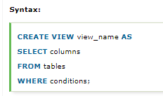
3. Example🡺

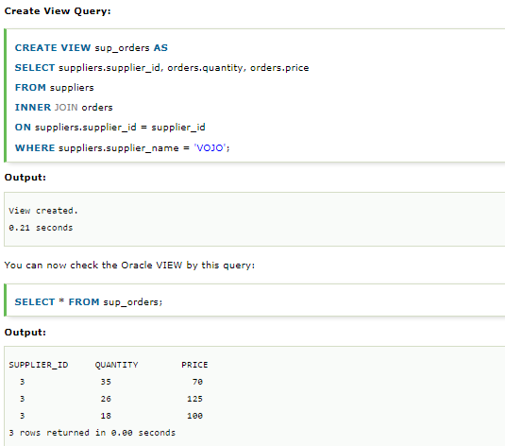

1. In Oracle, the CREATE OR REPLACE VIEW statement is used to modify the definition of an Oracle VIEW without dropping it.

Example🡺

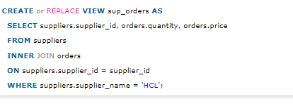

1. 
2. Now let’s see how to perform delete operation on view



1. Few of the restrictions on view for Modifying is 🡺

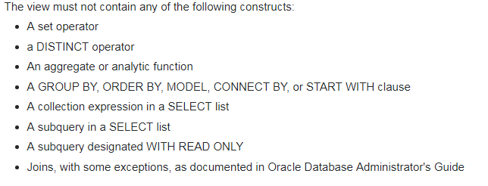

NOTE🡺 ALONG WITH THIS RESTRICTIONS I ALSO HAVE FEW OTHER RESTRICTIONS ALSO

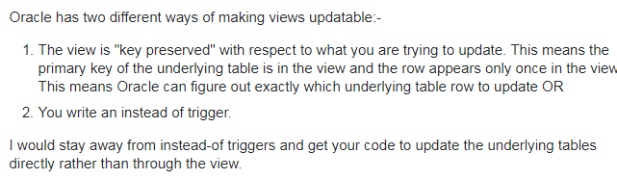

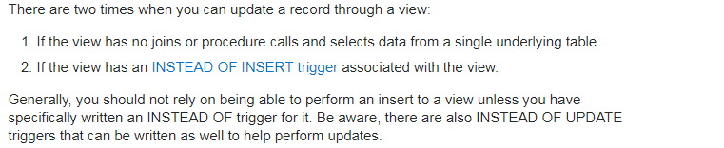

1. Needed more information on TOP, PARTITION, OVER, REGEXP_SUBSTR AND ETC IN PLSQL
2. CLEAR UNDERSTANDING OF CASE WITH AN EXAMPLE
3. Needed more information on the following🡺

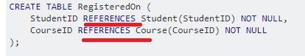

1. View, which is a logical table based on one or more tables or views. A view contains no data itself. The tables upon which a view is based are called **base tables**.
2. We have two types of Views, namely Object View and Relational View
3. A view is stored as a SELECT statement in the database. DML operations on a view like INSERT, UPDATE, DELETE affects the data in the original table upon which the view is based.
4. **View is used when we have to give access to limited amount of data. We can give permission to query a view for a table while denied access to the original table. It acts as a security measure.**

#### Modify Views

1. I was able to create a view for my table called usha_table, the view was having all the records as my table usha_table. But I was not able to do insert operation on View🡺 TRY THIS LATER
2. Deleting a row in a view could either mean deleting it from the base table or updating some values so that it is no longer selected by the view.
3. Inserting a row in a view could either mean inserting a new row into the base table or updating an existing row so that it is projected by the view.
4. Updating a column in a view that involves joins might change the semantics of other columns that are not projected by the view.

NOTE 🡺 MY UNDERSTANDING IS INSTEAD OF TRIGGER IS USED TO DO OPERATION ON VIEWS WHICH WILL INDIRECTLY MODIFIES THE BASE TABLE.

**Different ways of Inserting a values into database**

1. T

insert into EmpDtl2 (EmpName)

select EmpName from EmpDtl1

**Insert query result into new table**

select * into EmpCopy from EmpDtl1

1. Below query will insert data into table "EmpDtl1" returned by executing procedure.

insert into EmpDtl1

exec spGetEmpDetails

1. Suppose we want to create a table which is exactly the copy of a given table then we can also use the following Sql query

SELECT * INTO tbl_studentscopy FROM tbl_students

# 

**Can a view be updated/inserted/deleted? If Yes under what conditions?**

**A View can be updated/deleted/inserted if it has only one base table if the view is based on columns from one or more tables then insert, update and delete is not possible.**

Some other conditions on which DML Operation can be done on view is,

* View can be update/insert/delete if it contain fields of one table, **and 1.primary key should contain in select clause used for view**
* 2. But again if select stmt used in view contains group by clause then we can’t update view.
* 3. **If select clause contains more than one tables then we can use instead of trigger for dml operations**.

if the DML operation (Update/Delete/Insert) effects only one underlying table of your View the chances are you can do it. if the the operation effects more than one table you need to use Instead of Triggers

**Now let’s see the syntax for doing DML on Views (Created from more than one table) step by step**

Step 1 🡺Create these two table Employees and Department

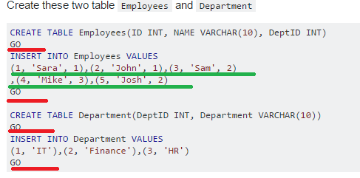

Step 2 🡺 Now let’s create the View

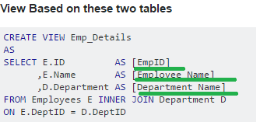

Another Example image I had pasted down for my understanding,

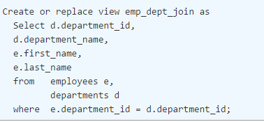

Step 3 🡺now let’s see the **Result Set of View**

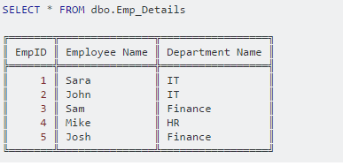

Step 4 🡺 **Do an Update on View 🡺**even though UPDATE only effects One underlying table.

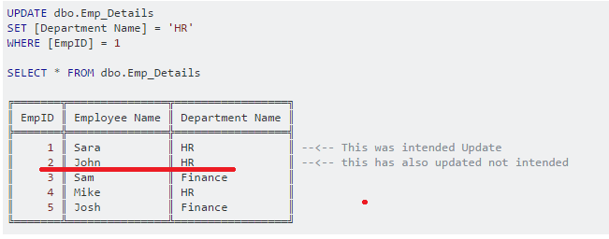

Now let’s see the **Department Table** after executing the above update on view,

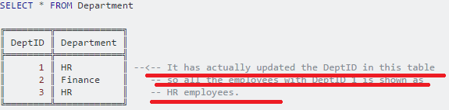

**Finally, I did all this because when you Issue an update statement against multiple Underlying tables it throws and error saying Update is not allowed because it effects multiple tables.**

**Now let’s see whether you can check whether the particular columns in a view are updateable or not:**

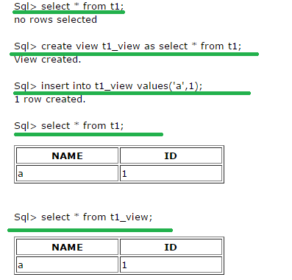

You can check whether the particular columns in a **view are updateable** or not🡺for the t1_view created above we can check like this

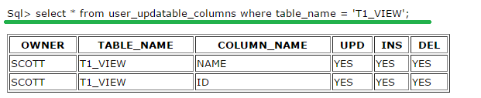

**Now let’s see how to make a View as Unmodifiable**

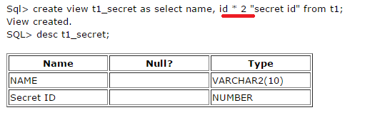

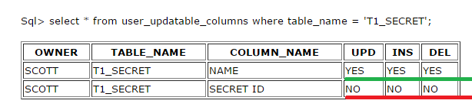

**Now let’s see the Syntax to create view WITH CHECK OPTION**

Step 1 🡺 Consider the following table with the records as shown below,

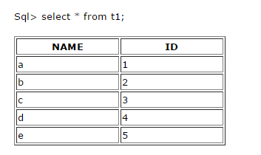

Step 2 🡺 Now let’s create a view,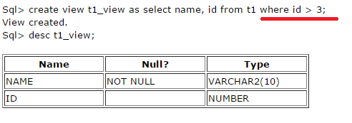

Step 3🡺 now let’s see the View data

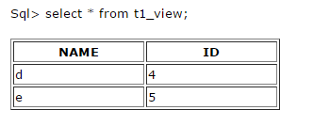

**Note 🡺if we insert any row in the table through view with id less than or equal to 3 it will let us insert that.**

**Now we will use *With Check* option to create that view again**:



NOTE 🡺 Now we will not be able to insert any row less than or equal to 3, only greater than 3 so as to match the view definition.

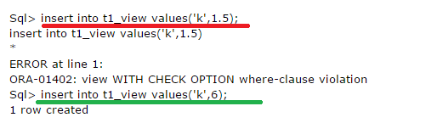

**Different way of updating an value into table**

## Updating Multiple Columns 🡺 Syntax below,

UPDATE Toy SET **ToyName = 'MagicSurfer',  Price = 15.99** WHERE ID = 4;

## Updating a Table Based on Values in a Different Table

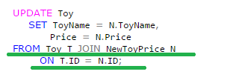

## Limiting the Rows that get Updated Using Top Clause

1. ms 🡺We already aware of “WHERE” clause which is used to limit the rows, in addition to where clause we also have TOP clause for limiting the rows.

Syntax 🡺

Needed to do hands on view to get clear understanding

Needed more information on Top and needed to do hands on Over(partition by colname)

This code updates two **random** rows in my Toy table because TSQL doesn’t guarantee order unless you have an order by clause.  **If you want to update two rows based on the ORDER BY clause then you will need to use the TOP clause in a sub query in conjunction with a WHERE constraint, like in the following example.**

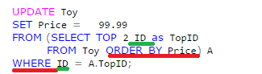

In order to have a clear understanding of the above query, let us see the Toy table structure first,

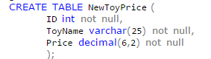

**Now let’s see the Insert query**

1. **Use INSERT IGNORE to ignore the duplicate rows**: Syntax 🡺**insert ignore into t1 select * from t2;**

**Note** 🡺 It only ignores rows that violate a unique index. If I have no unique index on a column, IGNORE has no effect.

## Inserting new rows and updating existing rows in a Single Query 🡺 LATER

1. Now let’s see the syntax for using the case in update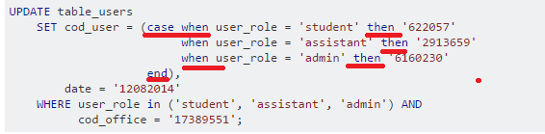

**Now let’s see the Working of Instead of Trigger with Example**

Step 1🡺 First let’s create a view for an Employee and Department table,



As the view consists of two table joins, it is illegal to insert records into this view as the insert requires both the underlying tables to be modified.

**By creating an instead-of trigger on the view, you can insert the records into both the underlying tables**. An example is shown below:

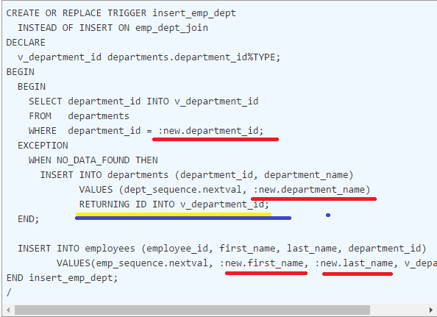

YELLOW and BLUE color 🡺 **see here its different insert Query is returning the Id column’s value that is the sequence number**

Needed practical example on :new.colname and :old.colname values

1/3/2017

**Update For**

1. The FOR UPDATE clause is an optional part of a [SELECT statement](http://docs.oracle.com/javadb/10.8.3.0/ref/rrefsqlj41360.html#rrefsqlj41360).
2. Cursors are read-only by default.
3. The FOR UPDATE clause specifies that the cursor should be updatable, and enforces a check during compilation that the SELECT statement **meets the requirements** for an updatable cursor , below screen shot is an example 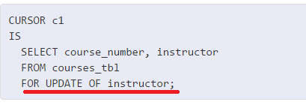
4. **Syntax 🡺**

**SELECT RECEIVED, SOURCE, SUBJECT, NOTE_TEXT FROM SAMP.IN_TRAY FOR**

**UPDATE**

Note 🡺 I tried executing the above query but was not able to run, I am getting the following error message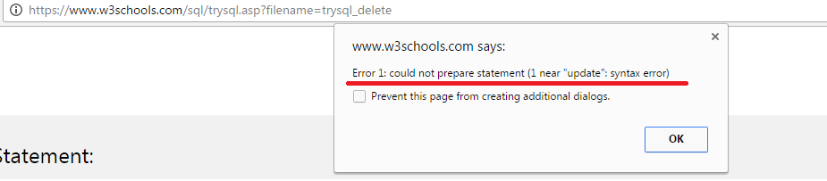

Few of the SQL points

1. Sql Functions
2. String functions🡺
3. Substr
4. Instr
5. Length
6. Concat
7. Upper/ lower/initcap
8. Numeric function
9. Round
10. Trunc
11. Mod
12. Date Functions
13. Sysdate
14. Systimestamp
15. Add_months
16. Next_day
17. Last_day
18. Character function
19. replace
20. Conversion function
21. To_char
22. To_date
23. How to find out even record and odd record🡺 ms by using RowId or RowNum
24. **Needed more information on Decode function**
25. **Needed more information on Over(), Partition and REGEXP_SUBSTR(-, -, -)**

PL-SQL

1. PL/SQL is a block structured language🡺 the block consist of three parts, or sections:
2. Declaration section
3. Executable section🡺 mandatory
4. Exception Handling section
5. Syntax🡺

**DECLARE**

Declarative Section

**BEGIN**

Executable Section

**EXCEPTION**

Error handling Section

**END**;

1. Dbms_output.put_line()
2. **Variable_name CONSTANTS datatype NOT NULL DEFAULT <VALUE>;**

Bonus CONSTANT number(4,2) := 11.25;

1. Data types,
   1. **Scalar data type**🡺 integer, int, positive, real, character, Boolean, varchar
   2. **Composite datatypes**🡺 Record, Table
   3. Reference datatypes🡺 Cursor
2. Variable_name tableName.columnName**%type**;
3. Variable_name tableName**%ROWTYPE**
4. Assigning values🡺**into** and “**:=**” 🡺 variable_name :=value

Select ename into variable_name from emp;

1. “select into” error conditions
   1. Failure🡺More than one row and not retrieve any row
   2. Success🡺 one row found
2. User interaction🡺&
   1. Values supplied by user can be stored in variables
   2. Values cannot be stored for **Boolean type**
   3. Select * from emp where emp_id = &userValue;

or

* 1. To avoid SQL injection🡺

userValue := &UValue;

Select * from emp where emp_id = &userValue;

1. - -🡺 single line comment
2. /*--------------*/ 🡺 multi line comment
3. IF <condition> THEN

Statements;

END IF**;**

1. IF <condition> THEN

Statements;

ELSE IF <condition> THEN

Statements;

ELSE IF <condition> THEN

Statements;

ELSE

Statements;

END IF**;**

1. We have **EXIT** and **EXIT WHEN**
2. We have 3 types of loops
   1. LOOP
   2. WHILE LOOP
   3. FOR LOOP
3. **Loop**

Statements;

If i=5 then

EXIT

End if;

**END LOOP;**

**EXAMPLE OF EXIT-WHEN**

**Loop**

Statements;

EXIT when i=5 ;

**END LOOP**

1. WHILE<condition> loop

Statements;

End loop;

1. FOR variable_name in [REVERSE] lower_bound..higher_bound

LOOP

Statements;

END LOOP;

1. <<label_name>> and goto
2. Nested blocks🡺

**DECLARE**

Declarative Section

**BEGIN**

Executable Section

--inner block begins

**DECLARE**

Declarative Section

**BEGIN**

Executable Section

**EXCEPTION**

Error handling Section

**END**;

--inner blocks ends

**EXCEPTION**

Error handling Section

**END**;

1. If we have Global variable and local variable with same name then in order to refer to the outer block or global variable we can use **LABEL NAME**
2. Record🡺

TYPE type_name is Record(emno emp.empNo%Type,

Ename emp.emp_Name%Type);

To access the record🡺 <record_variable_name> <record_type>

1. Cursors🡺2 types cursor🡺 implicit and explicit
2. PL/SQL implicitly declares a cursor for al SQL data manipulation statements
3. To process more than one row a programmer can declare an explicit cursor
4. Explicit cursor🡺
   1. Declare a cursor🡺

Cursor cursor_name is select emp_id from emp;

* 1. Open cursor_name;
  2. Fetch cursor_name into emp_id🡺 until all records are fetched,🡺 to check this condition we can use **EXIT** when **NOTFOUND** any records,
  3. close cursor_name

1. Attributes of explicit cursor
   1. cursor_name %NOTFOUND
   2. cursor_name %FOUND
   3. cursor_name %ROWCOUNT
   4. cursor_name %ISOPEN
2. similarly incase of implicit cursor
   1. SQL%NOTFOUND
   2. SQL%FOUND
   3. SQL%ROWCOUNT
   4. SQL%ISOPEN
3. Cursor FOR-LOOP syntax🡺

FOR variable_name IN cursor_name

LOOP

Statements;

END LOOP;

Or

FOR variable_name IN (SELCT EMPNO FROMEMP WHERE----)

LOOP

Statements;

END LOOP;

1. Cursor for **Update of where Current of**

Cursor cursor_name is select * from emp where deptno =10 for update of **columnName**

------

Update emp set **columnName** = mrecord.sal where current of cursor_name

1. Parameterized cursor🡺

Cursor cursor_name(**variable_name data_type**) is --------

While calling 🡺for variable_name in cursor_name(10)------

1. Exception🡺
   1. List of build in exception is 🡺later screen shot
   2. SQLCODE and SQLERRM
   3. EXCEPTION

When no_data_found **OR** too_many_rows then

Statements;

* 1. User Defined Exceptions
* We have to explicitly raise user defined exceptions as it wont be raised implicitly as build in exception
* We need to,
* Declare in declarative section
* Raise in executable section
* Handle it in exception handling section
  1. Syntax

**DECLARE**

**<EXCEPTION_NAME> exception**

**BEGIN**

RAISE <EXCEPTION_NAME>;

**Exception**

When < EXCEPTION_NAME> then

Statements;

**End**;

1. Needed more information on **PRAGMA EXCEPTION_INIT**
2. Example on RAISE_APPLICATION_ERROR

**DECLARE**

Declarative Section

**BEGIN**

------

Raise_application_error(-20000,”Hire Date should be less than System date”);

**EXCEPTION**

Error handling Section

**END**;

1. Sub-programs(or a program-unit)🡺is a named PL/SQL block
2. Actual and formal parameter 🡺

Actual parameter🡺 function_name_OR_Procedure_Name(10)

formal parameter🡺 function_name_OR_Procedure_Name(variable_name Data_type)

1. The parameters passed into the sub-programs can be three modes🡺
   1. In🡺 by default
   2. Out
   3. In out
2. Procedures🡺

Create or replace procedure procedure_name(parameter_name in/out/inout data_type:=default value) is

<pl/sql_block>

1. Positional, Named and Mixed Notation
2. Drop procedure Procedure_name
3. Function 🡺has at least one return value and one input
4. Syntax🡺

Create or replace function <function_name>(variable_name data_type) return data_type

Is

<PL/SQL block>

1. Drop function function_name
2. Package🡺 has 2 parts namely
   1. Specification
   2. Body
3. Specification syntax🡺

Create or replace package package_name as

Public variable_name data_type; **--ms**

procedure procedure_name;

function function_name(var_name datatype);

End;

1. Package body syntax🡺

Create or replace package body package_name

**As**

Procedure procedure_name

Is

PL/SQL block

-------

1. package_name. Procedure_name;
2. package_name. Function_name;
3. package_name. Cursor_name;
4. package_name. Variable_name;
5. **Overloaded Packages**
6. **One Time Procedures**
7. Drop package package_name
8. Triggers🡺An event which leads to action
9. Types🡺 Application(user log in and log off) and Database Trigger
10. Parts of Trigger
    1. Triggering event or statement
    2. Trigger restriction
    3. Trigger action
11. :NEW.column_name and :OLD_column_name🡺 needed to see practical example on NEW.column_name example
12. Syntax🡺

**Create or replace trigger trigger_name**

**After/before/instead of**

**Insert/update of column_names/delete**

**On**

**Table_name/view_name**

**For each row**

**When (<condition>)**

**<PL/SQL>**

1. Instead of trigger🡺 after covering
2. **Switch Example in PLSQL**
3. NEEDED MORE INFORMATION ON “WITHIN GROUP”,” REFERENCES”

XML

1. Stands for Extensible Markup language
2. Used to store and transport data
3. XM is used to carry data and HTML was designed to display data
4. Prolog is not mandatory in xml 🡺 suppose if appears means it should come in first line

<?xml version=”1.0”encoding=”UTF-8”?>

1. There are 5 pre-defined entity references in xml;
   1. &lt;
   2. &gt;
   3. &amp;
   4. &apos;
   5. &quot;
2. Comments 🡺 <!-- -->
3. Preserves white text between text unlike html
4. XML Namespaces🡺provide a method/way to avoid element name conflicts
5. **Needed more information on XPath**
6. XML validators🡺 either DTD(**Document Type Definition)** or XSD🡺 an xml document with correct syntax is called “WELL FORMED” and an XM document validated against a DTD or XSD is both well formed and VALID
7. DTD or XSD is used to define the structure of an xml
8. DTD syntax🡺 screen shot later
9. XSD syntax🡺 screen shot later
10. Xs:schema🡺 is a root tag of a xsd doc
11. <-- ----- xsi:schemaLocation=”” ------- >
12. Data types🡺
13. xs:string
14. xs:decimal
15. xs:integer
16. xs:Boolean
17. xs:date
18. xs:time
19. <xs:element name=”color” type=”xs:string” fixed=”red”/>
20. <xs:attribute name=”xxx” type =”yyy” default=”EN” />
21. <xs:attribute name=”xxx” type =”yyy” fixed=”EN” />
22. Optional and Required Attributes🡺default is optional🡺<xs:attribute name=”xxx” type =”yyy” use=”required” />
23. Simple type🡺<xs:element name=”” type=”simple type”>
24. Complex type🡺

<xs:element name=”” type=**”personalInfo**” />

<xs:complexType name =” personalInfo”>

<xs:sequence>

<xs:element name=”” type=”xs:string” />

<xs:element name=”” type=”xs:string” />

<xs:sequence>

</xs:complexType>

1. Complex type second example🡺 for reusability

<xs:element name=”” type=**”personalInfo**” />

<xs:element name=”” type=**”personalInfo**” />

<xs:element name=”” type=**”personalInfo**” />

<xs:complexType name =” personalInfo”>

<xs:sequence>

<xs:element name=”” type=”xs:string” />

<xs:element name=”” type=”xs:string” />

<xs:sequence>

</xs:complexType>

1. XSD indicators
2. Order🡺 All, Sequence, Choice(indicates that either one child element or another can occur)🡺 needed an example on **Choice order**
3. Occurrence🡺minOccurs(default value is 1), maxOccurs
4. Group🡺 screen shot later

**XSD/XML extra information which was not present in the xml notes that I have**

### Element Groups:

1. Element groups are defined with the group declaration, like this:

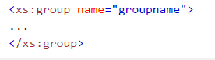

1. You must define an all, choice, or sequence element inside the group declaration.
2. The following example defines a group named "persongroup", that defines a group of elements that must occur in an exact sequence: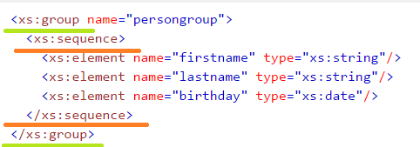

* attributeGroup name

1. 

## XSD the <any> Element and The <anyAttribute> Element

# XSD Element Substitution🡺Later

# XSD Restrictions/Facets

1. Restrictions are used to define acceptable values for XML elements or attributes.
2. Restrictions on XML elements are called **facets**.

# Restrictions on Values

1. 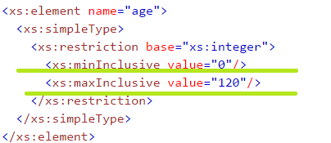

# Restrictions on a Set of Values

1. To limit the content of an XML element to a set of acceptable values, we would use the enumeration constraint.
2. 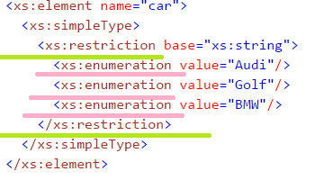

# Restrictions on a Series of Values

1. To limit the content of an XML element to define a series of numbers or letters that can be used, we would use the pattern constraint.
2. The example below defines an element called "letter" with a restriction. The only acceptable value is **ONE** of the LOWERCASE letters from a to z:

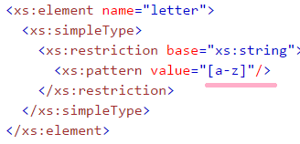

1. Another example:

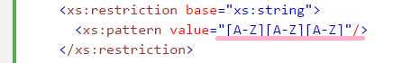

1. Example🡺The only acceptable value is THREE of the LOWERCASE OR UPPERCASE letters from a to z

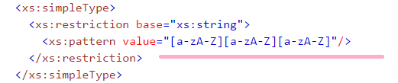

1. Example🡺The only acceptable value is ONE of the following letters: x, y, OR z

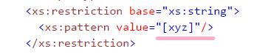

1. Example🡺The acceptable value is **zero or more** occurrences of lowercase letters from a to z

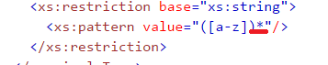

1. Example🡺The only acceptable value is **male OR female**

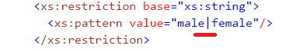

1. And See the tutorial for other examples…..
2. **Restrictions on Length**
3. To limit the length of a value in an element, we would use the **length, maxLength, and minLength** constraints.
4. Example🡺The value must be exactly eight characters



1. The value must be minimum five characters and maximum eight characters,

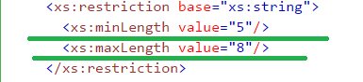

Html and CSS🡺 See the prepared notes that itself is shortly written

1. List of Newly found styles in Angular Documentation Notes is needed information on this,

* list-style-type: none;
* cursor: pointer;’
* position: relative;
* left: 0;
* border-radius: 4px;
* border-radius: 4px 0 0 4px;
* display: inline-block;
* padding: 0.8em 0.7em 0 0.7em;
* line-height: 1em;
* left: -1px;
* top: -4px;
* font-weight
* display: inline-block;
* text-decoration: none;

JavaScript

1. 
2. 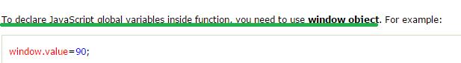
3. JS primitive data types🡺string, boolean, number, null and undefined
4. JS non-primitive or advanced data type 🡺Object, array and **RegExp**
5. JS special operators🡺(?:), delete, in, instanceOf, typeOf, void, yield and ,

**Yield🡺 checks what is returned in a generator by the generator's iterator.**

1. What is the difference between compilation and translation🡺

* **Compilation** is transforming code in a higher-level language to a lower-level one. Examples: Java to Java Bytecode, or C to x86 machine code.
* **Decompilation** is transforming a code in a lower-level language to a higher-level one - in effect, the opposite of compilation. Examples: Java Bytecode to Java.
* **Translation** or **source-to-source compilation** is transforming a code in some language to another language of comparable "level". Examples: ARM to x86, or C to Java. When the two languages are actually different versions of the same language (e.g. Javascript 6 to Javascript 5), the term **transpiler** is also used.

1. Needed more information on “for-in” loop in Javascript
2. 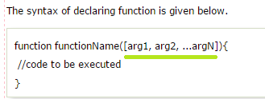
3. 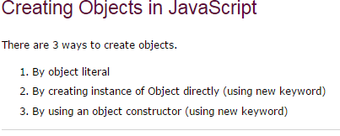
4. 
5. By Creating instance of Object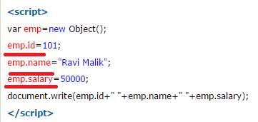
6. By Using the Object Constructor🡺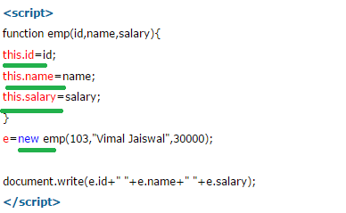
7. Defining an method in the JS obj🡺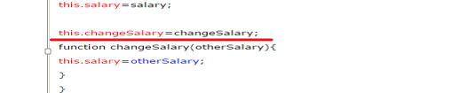
8. In JS Array is created in 3 ways🡺

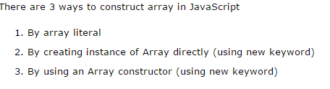

1. 
2. 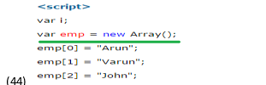
3. 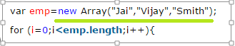
4. JS string is created in 2 ways,
5. By String literal🡺 var stringname="string value";
6. **By string Obj🡺  var stringname=new String("string literal");**
7. JS String methods,

* charAt(index), concat(str), indexOf(str), lastIndexOf(str), toLowerCase(), toUpperCase(),slice(beginIndex, endIndex), trim()

1. BOM🡺Browser object model

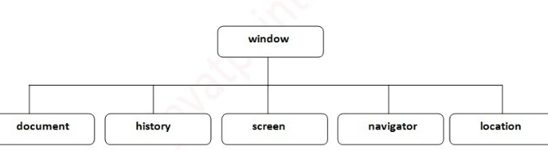

1. **Window is the object of browser, it is not the object of JavaScript**
2. window object method🡺alert()🡺ok button, confirm()🡺 ok and cancel button, prompt()🡺 has input text field and 2 buttons(ok, cancel), open()🡺 new browser window, close()🡺 Closes the current browser window, setTimeout()

setTimeout ()🡺performs action after specified time like calling function, evaluating expressions etc.

1. dom🡺 document object model🡺 ms represents HTML page object
2. dom Methods 🡺write(String), write(String), getElementById(),getElementByName(),getElementByTagName(), getElementByClassName()
3. we are going to get the value of input text by user. Here, we are using **document.form1.name.value** to get the value of name field.

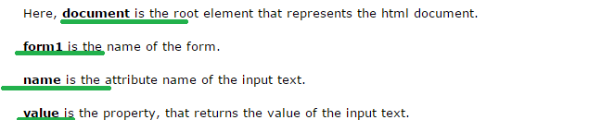

1. The **innerHTML** property can be used to write the dynamic html on the html document 🡺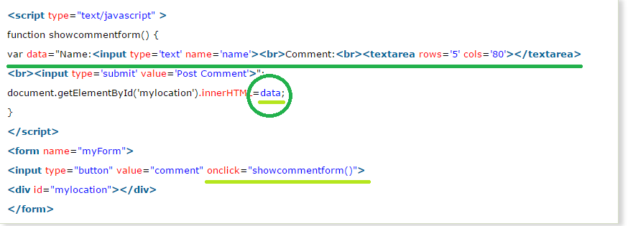
2. The **innerText** property can be used to write the dynamic text on the html document. Here, text will not be interpreted as html text but a normal text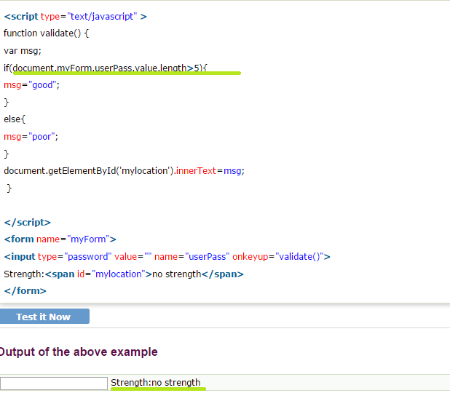
3. JavaScript number validation🡺 **Here, we are using isNaN() function to identify valid number is entered by user or not**
4. SEE THE KOUSHIK NOTES ON JS🡺Prototype and some basic information

JQuery

1. JQuery lightweight JavaScript library.
2. JQuery means "write less do more". jQuery simplifies AJAX call and DOM manipulation
3. **jQuery is developed by Google.**
4. **To create the first jQuery example, you need to use JavaScript file for jQuery. You can download the jQuery file from jquery.com or use the absolute URL of jQuery file.**
5. Syntax for absolute URL is shown below



Note: In another Script tag we can write our JavaScript/JQuery Code

1. 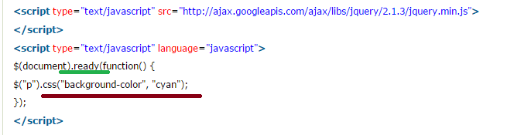
2. In place of $(document).ready(), you can use shorthand notation $() only.,

Example🡺

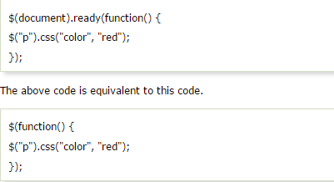

1. **All jQuery selectors start with a dollar sign and parenthesis e.g. $(). It is known as the factory function.**
2. 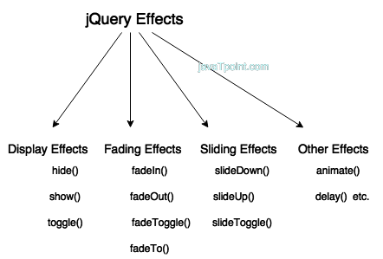
3. Some of the CSS Selectors that was new
   1. 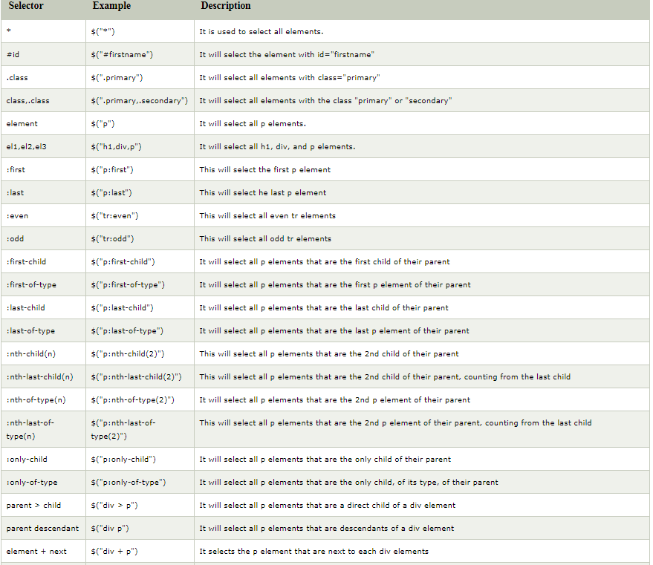
   2. 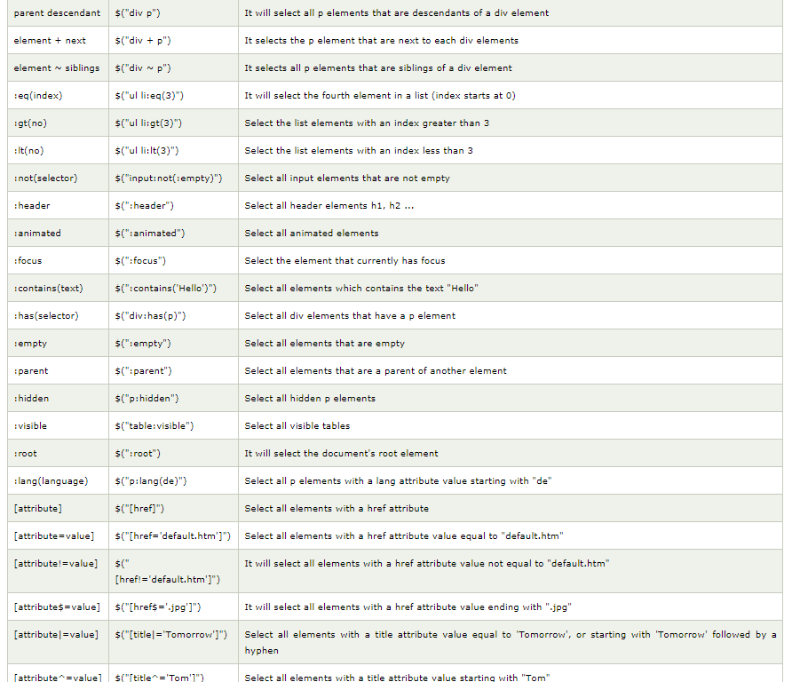
   3. 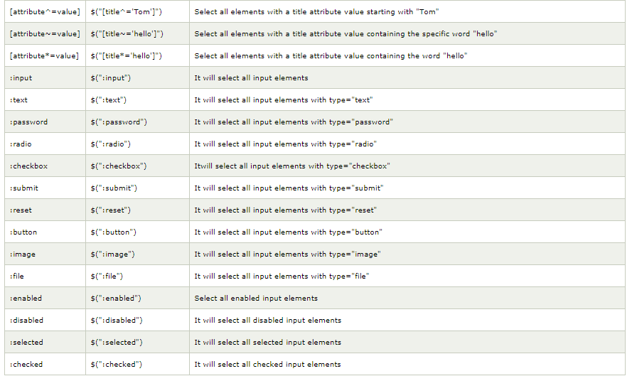
4. jQuery Functions🡺
5. Graphic or UI Style related Functions,

clearQueue(),delay(),queue(), dequeue(),fadein(),fadeout(),fadeto(),fadetoggle(),finish(),hide(),show(),toggle(),slidedown(),slidetoggle(),slideup(),stop(),

1. CSS and HTML functions

In this Notes, I had Removed Struts and JMS

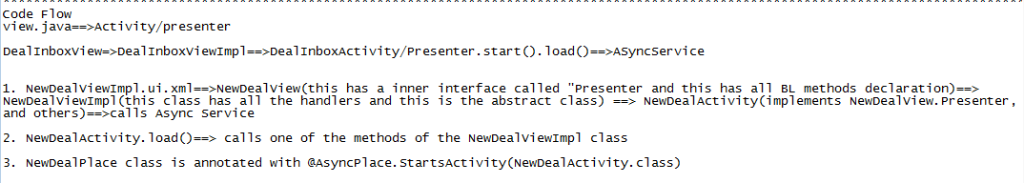

* + 1. What is the full form of SVN, Jenkins,

**SVN is a shorthand abbreviation of the name “Subversion”. For those who have not heard of it, Subversion is a powerful open-source version control system that is typically used to manage the collections of files that make up software projects.**

Hibernate interview Questions 🡺 from Journal dev

1. Hibernate is java based ORM tool that provides framework for mapping application domain objects to the relational database tables and vice versa.
2. Java Persistence API (JPA) provides specification for managing the relational data in applications.
3. **What is the JPA version we use in our project?**
4. Advantages of hibernate,
5. Hibernate framework provides support for XML as well as JPA annotation
6. Hibernate supports lazy initialization using proxy objects and perform actual database queries only when it’s required.

**Why do hibernate uses Lazy initialization?**

**Note🡺is Lazy initialization is present in the Collections which are Non Entity type? 🡺 for example @ElementCollection in such Examples**

**What happens if I do empty.property/method in java**

1. Hibernate supports JPA annotations, so code is independent of implementation and easily replaceable with other ORM tools. JDBC code is very tightly coupled with the application
2. List of few annotations which we have not seen

* **javax.persistence.Access**: 🡺 Used to define the access type, either field or property. Default value is field and if you want hibernate to use getter/setter methods then you need to set it to property. 🡺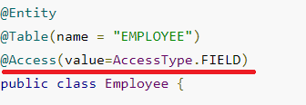
* **org.hibernate.annotations.Cascade 🡺**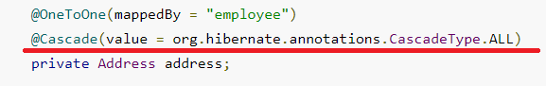
* **javax.persistence.PrimaryKeyJoinColumn 🡺** Used to define the property for foreign key. Used with org.hibernate.annotations.GenericGenerator and org.hibernate.annotations.Parameter 🡺NEEDED CLEAR UNDERSTANDING ON THIS EXAMPLE

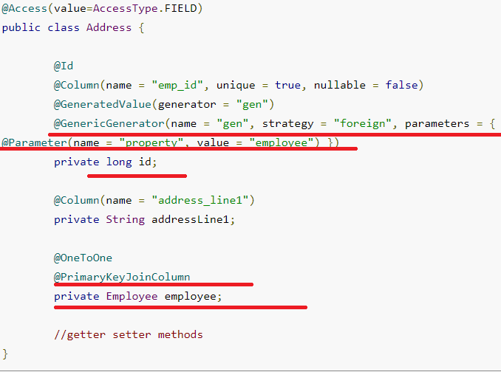

1. Hibernate Session is the interface between java application layer and hibernate.
2. MS🡺Once the session factory is closed, session object gets closed. 🡺 check whether we are doing any close of emf, em or sf or session
3. What is Hibernate Cache🡺hibernate caches query data to make our application faste
4. 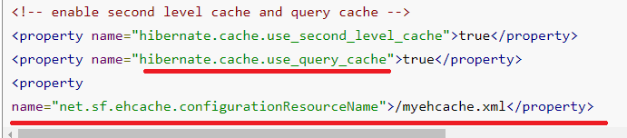

Query cache is an optional feature and requires two additional physical cache regions that hold the cached query results and the timestamps when a table was last updated.

1.  🡺 for this if we do any write operation then we will get UnSupportedOperationException

### What are different states of an entity bean? 🡺Transient, persistent and detached

1. Hibernate merge() can be used to update existing values, however this method create a copy from the passed entity object and return it. The returned object is part of persistent context and tracked for any changes, passed object is not tracked.
2. What is the difference between merge() and Update()🡺 needed clear understanding
3. **What is difference between Hibernate save(), saveOrUpdate() and persist() methods?**

Ms🡺 persist() 🡺 does not have any return value its void

1. What will happen if we don’t have no-args constructor in Entity bean?

**Hibernate uses**[**Reflection API**](https://www.journaldev.com/1789/java-reflection-example-tutorial)**to create instance of Entity beans, usually when you call get() or load() methods. The method Class.newInstance() is used for this and it requires no-args constructor. So if you won’t have no-args constructor in entity beans, hibernate will fail to instantiate it and you will get HibernateException.**

1. 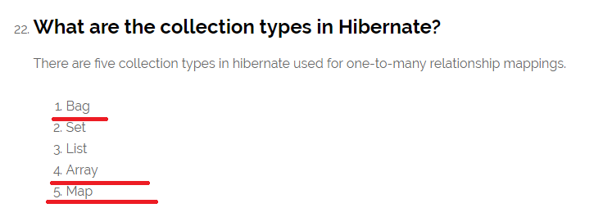 **🡺 needed to do hands on Bag, Array and Map**

### How to implement Joins in Hibernate? 🡺

* Using associations such as one-to-one, one-to-many etc.
* Using JOIN in the HQL query.
* We can fire native sql query and use join keyword.

### Why we should not make Entity Class final? 🡺 Hibernate use proxy classes for lazy loading of data, only when it’s needed. This is done by extending the entity bean, if the entity bean will be final then lazy loading will not be possible, hence low performance.

### What is HQL and what are it’s benefits? 🡺 Hibernate Framework comes with a powerful object-oriented query language – Hibernate Query Language (HQL). Hibernate query language is case-insensitive except for java class and variable names.

### Lazy loading is a technique in which objects are loaded on demand basis. Since Hibernate 3, lazy loading is by default, enabled so that child objects are not loaded when parent is loaded 🡺 from Tutorials point interview Question

1. **Hibernate provide option to execute native SQL queries through the use of SQLQuery object.**
2. Hibernate provides Named Query (ms or Named Query) that we can define at a central location(ms on the entity) and use them anywhere in the code.
3. **Hibernate provides Criteria API that is more object oriented for querying the database and getting results. We can’t use Criteria to run update or delete queries or any DDL statements. It’s only used to fetch the results from the database using more object oriented approach.**
4. How to log hibernate generated sql queries in log files? 🡺
5. 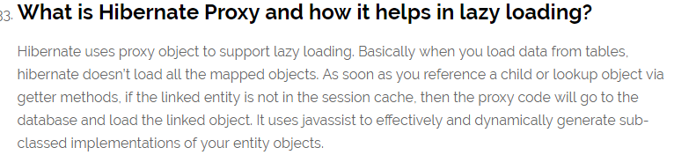
6. Commonly used cascading types as defined in CascadeType enum are: 🡺 None, ALL, SAVE_UPDATE, DELETE, DETATCH, MERGE, PERSIST, REFRESH and REMOVE, LOCK, REPLICATE 🡺 **see for a practical example on all this cascade type**
7. 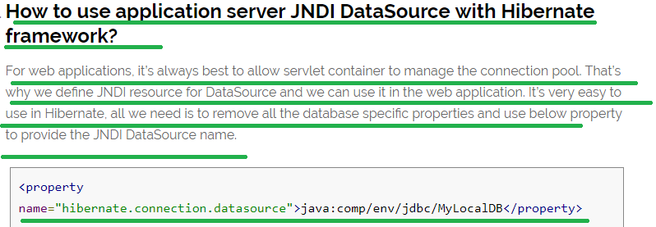

[Hibernate JNDI DataSource Example](https://www.journaldev.com/2905/hibernate-tomcat-jndi-datasource-example-tutorial).

### NEEDED TO KNOW WHAT IS DIFFERENCE BETWEEN JNDI DATASOURCE AND <JTA-DATA-SOURCE>

### Note 🡺 in our real world app “java:comp/env/jdbc/cwf” this was the value used for <JTA-DATA-SOURCE>

### And when I saw in the WebSphere Console the JNDI name was “jdbc/cwf”

### Needed more information on transaction-type attribute of the <persistence-unit> element in the persistence.xml file 🡺 see below points

### Which design patterns are used in Hibernate framework?

* [Proxy Pattern](https://www.journaldev.com/1572/proxy-design-pattern) for lazy loading
* [Factory pattern](https://www.journaldev.com/1392/factory-design-pattern-in-java) in SessionFactory

### 

# [**Need explanation of “jta-data-source”**](https://stackoverflow.com/questions/25918389/need-explanation-of-jta-data-source) 🡺 from stack overflow

1. the following line in a persistence.xml 🡺
2. 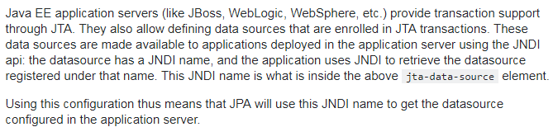

# [**Difference between a “jta-datasource” and a “ resource-local ” datasource?**](https://stackoverflow.com/questions/3217586/difference-between-a-jta-datasource-and-a-resource-local-datasource) **🡺 from stack overflow**

**QUESTION Part🡺**The terms "jta-datasource" and "resouce-local datasource" are a little vague to me.

**Answer part** 🡺

* I guess you actually refer to the jta-datasource and non-jta-datasource elements. In short:
* if the transaction type of the persistence unit is *JTA*, the jta-datasource element is used to declare the JNDI name of the JTA data source that will be used to obtain connections. This is the common case.

For example 🡺

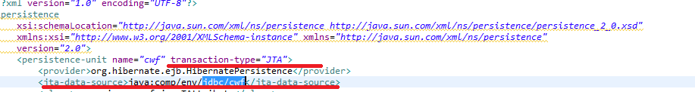

In the WebSphere🡺

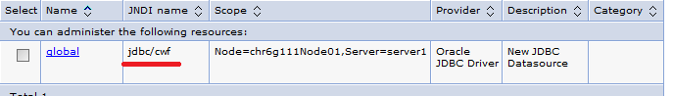

* if the transaction type of the persistence unit is *resource-local*, the non-jta-data-sourceshould be used to declare the JNDI name of a non-JTA data source.

1. **QUESTION Part🡺** The same database can be referred to as a jta-datasource or as a resource local datasource

**Answer part** 🡺

* This is correct. And I didn't mention that just above but some providers even allow to declare both a jta-datasource **and** a non-jta-datasource and use the later for optimized reading through non-JTA connections (i.e. that won't be associated to an ongoing JTA transaction).

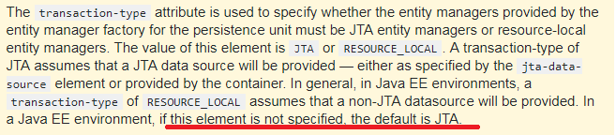

# [What is the difference between JTA and a local transaction?](https://stackoverflow.com/questions/9552718/what-is-the-difference-between-jta-and-a-local-transaction) from stack overflow

1. Transaction-type should be set to "RESOURCE_LOCAL" for Java SE application and to "JTA" for Java EE application. "RESOURCE_LOCAL" may work fine on some web application deployed on Tomcat, but may cause issues when you run your application under glassfish environment. If you are working on distributed transactions you must use "JTA" as your transaction manager.
2. The Java Transaction API (JTA) is one of the Java Enterprise Edition (Java EE) APIs allowing distributed transactions to be done across multiple XA resources in a Java environment.

List of 5 common hibernate Exceptions

1. LazyInitializationException
2. OptimisticLockException 🡺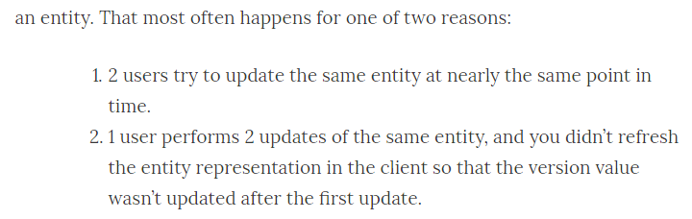
3. 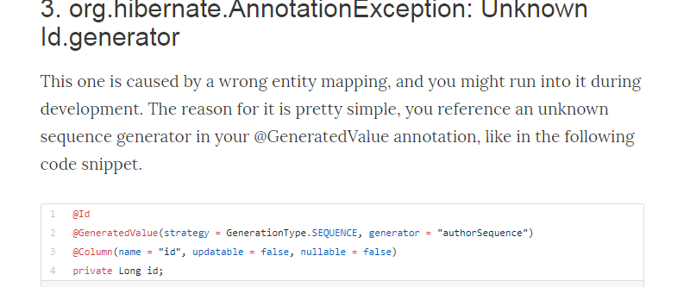
4. c

Spring from Journal dev🡺 this website also has some of the advanced topic which I have not covered

1. Spring is a java EE framework. It’s core concepts are “Dependency Injection” and “Aspect Oriented Programming”. Used to achieve loose coupling
2. **See the Advantages of Spring framework later**

* Predefined Templates
* Loose Coupling
* Easy to test
* Lightweight
* Fast Development
* Powerful Abstraction
* Declarative support

1. Dependency Injection design pattern allows us to remove the hard-coded dependencies and make our application loosely coupled, extendable and maintainable

Note🡺 We can implement dependency injection pattern to move the dependency resolution from compile-time to runtime 🡺 ms through static and nostaic factory methods

1. We can use Spring XML based as well as Annotation based configuration **to implement DI in spring applications**
2. 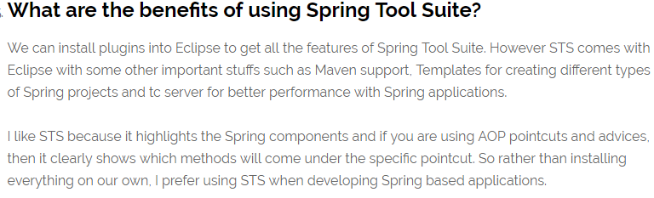
3. Any normal java class that is initialized by Spring IoC container is called Spring Bean. We use Spring ApplicationContext to get the Spring Bean instance.
4. 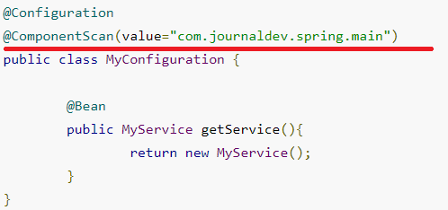
5. AnnotationConfigApplicationContext object is used to get the beans instance in case of the Annotation based configuration
6. Few annotations used in spring is
7. **@Component🡺 needed more information on this**
8. **@Controller🡺 used in mvc**
9. **@Repository** annotation is used to indicate that a component is used as repository and a mechanism to store/retrieve/search data. We can apply this annotation with DAO pattern implementation classes.
10. **@PathVariable** – for mapping dynamic values from the URI to handler method arguments.
11. **@Service is used to indicate that a class is a Service. Usually the business facade classes that provide some services are annotated with this. 🡺 NEEDED TO SEE REAL TIME EXAMPLE**
12. 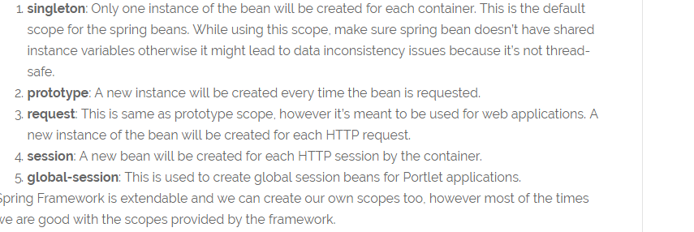
13. 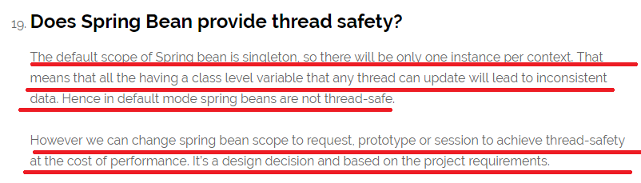
14. 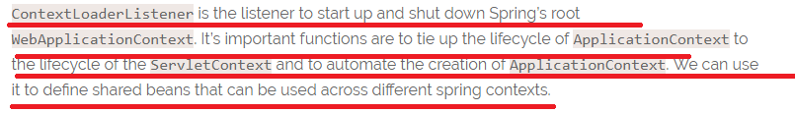

### How to handle exceptions in Spring MVC Framework? 🡺 IS NEW CONCEPT

### How to create ApplicationContext in a Java Program🡺 **AnnotationConfigApplicationContext, ClassPathXmlApplicationContext, FileSystemXmlApplicationContext**

1. 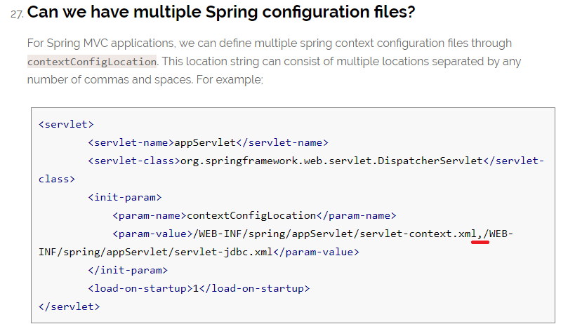
2. **Spring with Restful service🡺 example is explained see it later**
3. File Upload using spring🡺 see Tpoint or journal dev later
4. 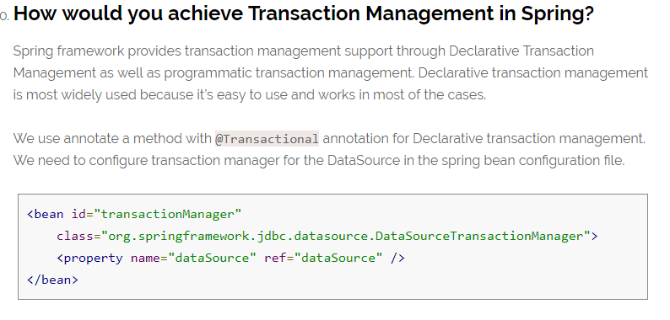

String Methods

1. [**char charAt(int index)**](https://www.tutorialspoint.com/java/java_string_charat.htm)
2. [**int length()**](https://www.tutorialspoint.com/java/java_string_length.htm)
3. [**int compareTo(Object o)**](https://www.tutorialspoint.com/java/java_string_compareto.htm)
4. [**int compareToIgnoreCase(String str)**](https://www.tutorialspoint.com/java/java_string_comparetoignorecase.htm)
5. [**boolean equals(Object anObject)**](https://www.tutorialspoint.com/java/java_string_equals.htm)
6. [**boolean equalsIgnoreCase(String anotherString)**](https://www.tutorialspoint.com/java/java_string_equalsignorecase.htm)
7. [**String concat(String str)**](https://www.tutorialspoint.com/java/java_string_concat.htm)
8. [**boolean contentEquals(StringBuffer sb)**](https://www.tutorialspoint.com/java/java_string_contentequals.htm)
9. [**static String copyValueOf(char[] data)**](https://www.tutorialspoint.com/java/java_string_copyvalueof.htm)
10. [**void getChars(int srcBegin, int srcEnd, char[] dst, int dstBegin)**](https://www.tutorialspoint.com/java/java_string_getchars.htm) 🡺 Copies characters from this string into the destination character array.
11. [**CharSequence subSequence(int beginIndex, int endIndex)**](https://www.tutorialspoint.com/java/java_string_subsequence.htm)
12. [**char[] toCharArray()**](https://www.tutorialspoint.com/java/java_string_tochararray.htm)
13. [**boolean endsWith(String suffix)**](https://www.tutorialspoint.com/java/java_string_endswith.htm)
14. [**boolean startsWith(String prefix)**](https://www.tutorialspoint.com/java/java_string_startswith.htm)
15. [**byte getBytes()**](https://www.tutorialspoint.com/java/java_string_getbytes.htm)
16. [**byte[] getBytes(String charsetName)**](https://www.tutorialspoint.com/java/java_string_getbytes_charsetname.htm)
17. [**int indexOf(int ch)**](https://www.tutorialspoint.com/java/java_string_indexof.htm) 🡺 overloaded for String also
18. [**int indexOf(int ch, int fromIndex)**](https://www.tutorialspoint.com/java/java_string_indexof_fromindex.htm) 🡺 overloaded for String also
19. [**int lastIndexOf(int ch)**](https://www.tutorialspoint.com/java/java_string_lastindexof.htm)🡺 overloaded for String also
20. [**int lastIndexOf(int ch, int fromIndex)**](https://www.tutorialspoint.com/java/java_string_lastindexof_chfromindex.htm)🡺 overloaded for String also
21. [**boolean matches(String regex)**](https://www.tutorialspoint.com/java/java_string_matches.htm)
22. [**String replace(char oldChar, char newChar)**](https://www.tutorialspoint.com/java/java_string_replace.htm) 🡺 overloaded for String also
23. [**String replaceFirst(String regex, String replacement)**](https://www.tutorialspoint.com/java/java_string_replacefirst.htm)
24. [**String replaceAll(String regex, String replacement**](https://www.tutorialspoint.com/java/java_string_replaceall.htm)
25. [**String[] split(String regex)**](https://www.tutorialspoint.com/java/java_string_split.htm)
26. [**String substring(int beginIndex)**](https://www.tutorialspoint.com/java/java_string_substring.htm)
27. [**String substring(int beginIndex, int endIndex)**](https://www.tutorialspoint.com/java/java_string_substring_beginendindex.htm)
28. [**String trim()**](https://www.tutorialspoint.com/java/java_string_trim.htm)
29. [**static String valueOf(primitive data type x)**](https://www.tutorialspoint.com/java/java_string_valueof.htm)
30. toString

🡺Binary Search, Bubble sort, sorting,

String Program Question

1. Program🡺 **How do you remove all white spaces from a string in java?**

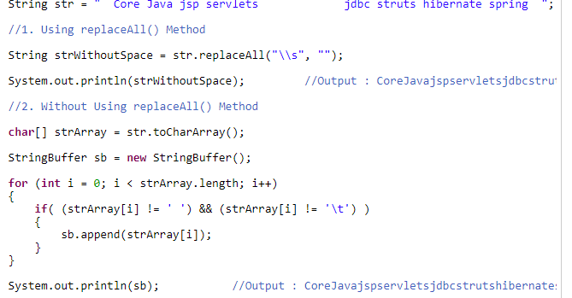

1. **How do you find duplicate characters in a string? And How do you count the number of occurrences of each character in a string? Both are almost the same**
2. **Write a java program to reverse a string? Program🡺**

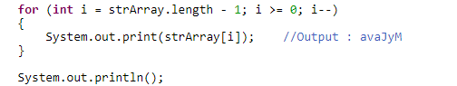

## **Anagram**

1. Two strings are called anagrams if they contain same set of characters but in different order. For example, **“Dormitory – Dirty Room”**, **“keep – peek”,  “School Master – The Classroom”** are some anagrams.

Logic🡺 First we clean the input by removing all white spaces from the given two strings and change the case of all characters of both the strings to lower case so that case of both input strings will be ignored. After cleaning the input strings, we convert them to character array and sort them using **sort() method** of java.util.Arrays class. After sorting, we compare both the arrays using **equals() method** of same Arrays class.

1. **Write a code to check whether one string is a rotation of another?**
2. **Write a java program to reverse a given string with preserving the position of spaces?**

Write a java program to reverse a string with preserving the position of spaces. For example, if **“I Am Not String”** is the given string then the reverse of this string with preserving the position of spaces is **“g ni rtS toNmAI”**.

So While reversing a string I should maintain the position 🡺 ms it should be “gnirts ton mA I”

**Logic🡺 First, we convert the given ‘inputstring’ to char array and call it as ‘inputStringArray’. We define one more char array**

**called ‘resultArray’ with the same size as ‘inputStringArray’. In the first for loop, for every space in the ‘inputStringArray’,**

**we insert space in the ‘resultArray’ at the corresponding positions. In the second for loop,**

**we copy non-space characters of ‘inputStringArray’ starting from first to last into the ‘resultArray’ at ‘j’ position where ‘j’**

**will have value from length of resultArray to 0. Before copying, we check whether the ‘resultArray’ already contains a space at index ‘j’**

**or not. If it contains, we copy the character in the next position. See the below image for more clarity.**

1. **Write a java program to reverse each word of a given string? 🡺 Ms Lets see this by using string tokenizer home work**
2. **Swap 2 numbers without temporary variable🡺 x=20 and y =10 🡺**
3. Bubble sort 🡺 is Normal Sorting in Asc order/desc🡺 see java Tpoint
4. Binary Search🡺 No Idea
5. See Qspider notes for few Program Examples

**Needed to See Junit and Log4j, JNDI, JTA_data source**